Student Enrollment Analysis System

(SEAS)

**final project report**

**gROUP – 05**

|  |  |
| --- | --- |
| **NAME** | **ID** |
| MD ZAKARIA KABIR | 1921371 |
| SUMAIA ANJUM SHABA | 1920932 |
| Ahad Al Tanvir Ahmed | 1920468 |
| Quazi Munzur E Ellahi Ruhin | 1930274 |
| Fayeeza Subah Islam | 1920044 |
| Nusrat Jahan | 1921793 |

CONTENTS

Chapter 1- Introduction 5

A. Background Of The Organization 6

B. Background Of The Project Seas 6

C. Objectives Of The Project 6

D. Scope Of The Project 7

Chapter 2-Requirement Analysis 8

A. Rich Picture – Existing Business System 8

B. Six Elements Analysis - Existing Business System 10

C. Process Model – Existing Business System 28

D. Problem Analysis – Existing Business System 32

E. Rich Picture - Proposed System 36

F. Six Elements Analysis – Proposed System 37

G. Process Model - Proposed System 50

Chapter 3- Logical System Design 52

A. Business Rule 52

B. Entity Relationship Diagram 53

C. Entity Relationship Diagram To Relational Schema: 54

D. Normalization 54

E. Data Dictionary 56

Chapter 4- Physical System Design: 60

A. Input Form: 60

B. Output Forms: 94

Chapter 5 - Conclusion: 113

A. Problem And Solution: 113

I. Analysis Phase 113

Ii. Designing Phase 113

Iii. Implementation Phase 113

B. Additional Feature And Future Development: 113

References 114

LIST OF FIGURES

Figure 1: Rich Picture of Existing System 9

Figure 2: Datasheet Distribution 29

Figure 3: Enrollment wise course distribution analysis 29

Figure 4: Revenue analysis. 30

Figure 5: Resources analysis 30

Figure 6: Classroom requirement analysis 31

Figure 7: Accumulate School based analysis. 31

Figure 8: Rich Picture for Proposed System 36

Figure 9: Import dataset into the system. 50

Figure 10: View System generated resource analysis. 50

Figure 11: View system generated Revenue Analysis. 51

Figure 12: View Classroom requirement analysis. 51

Figure 13: View enrollment wise course distribution analysis. 51

Figure 14: Entity Relationship Diagram 53

Figure 15: Relational Schema 54

# Chapter 1- Introduction

A student is admitted to a university under a certain degree program. Each program is assigned to a department, which is listed under Schools. Students generally take courses according to their program's curriculum, which typically includes:

* Business & Entrepreneurship
* Engineering, Technology & Sciences
* Environment and Life Sciences
* Liberal Arts & Social Sciences
* Pharmacy and Public Health

The purpose of this report is to examine IUB's current student enrollment analysis system, conduct the necessary process analysis, and propose a new and improved system that reduces error, makes data analysis, report, and chart generation easier for all stakeholders, and produces/shows valuable information for IUB and its collaborators in order to make necessary improvements. The first section delves into the specifics of the organization in issue as well as the project we've undertaken for them. The second section focuses on the existing system and its flaws, as well as an introduction to the proposed system that would be used to replace it. The third and fourth sections will be highly technical, focusing on how we intend to implement the proposed system.

According to our investigation into the current system of student enrollment analysis, we've discovered places where some important modifications are necessary to make the system more efficient and facilitate communication among stakeholders. Furthermore, the modifications will eliminate the possibility of human mistake and data duplication, and stakeholders will be able to access a vast dataset and review valuable information through our system rather of reading through documents manually.

As we progress through the report, we'll look at how the present student enrollment analysis system works, the business processes involved, where there are concerns and difficulties with data management, and how we can create a better system to remedy and enhance these problems.

## A. Background of the organization

Established in 1993, Independent University, Bangladesh (IUB) is one of Bangladesh's oldest private institutions, with an estimated 8,423 undergraduate and graduate students, 13,745 alumni, and 401 faculty members. [1]

Our academic curriculum is based on a North American liberal arts model and the medium of instruction is English. We currently have six academic schools: School of Business, School of Engineering and Computer Science, School of Environmental Sciences and Management, School of Liberal Arts and Social Sciences, School of Life Sciences and School of Public Health**.** [1]

Only by being disciplined and up to date with the on-going curriculum and development system has IUB demonstrated outstanding results in creating graduates with marketable abilities over time. Investing in IUB's departments, particularly the Department of Computer Science and Electrical Science, in order to turn it into a well-funded research facility with several research programs. IUB is likewise dedicated to developing international-standard graduates who are primarily prepared to lead the national economy through skilled employment, entrepreneurship, and/or applied research.

## B. Background of the project SEAS

The project's goal is to develop a software system for stakeholders and institutional bodies to retrieve statistical data on school-level revenue analysis, classroom requirement analysis based on class slot, classroom allocation recommendations based on IUB best resource utilization, and IUB resource calculation.

## C. objectives of the project

To meet the purpose of the project several requirements must be met.

Our system SEAS will provide the users with the requested analysis and allow them to view it in tables and particular charts. The stakeholders – department/school/ High authority/Registrar’s office will log into our system and select which analysis that is class requirement per slots, revenue analysis, resource utilization, available resource they want to see. The system will take the necessary information from SEAS database which is the extracted information from the provided tally sheet. SEAS will form a table on classroom requirements based on class size, total slots per day for any individual semester and if the user request to see a pie chart on distribution of the classrooms per class size, then the system based on the table formed will generate a pie chart. SEAS will generate table on based the number of sections offered per school for selected class size with respect to the total number of sections in every semester for entire university. The system will provide an analysis for the number of classrooms available per class size and number of classrooms required. It will also provide a revenue analysis based on each department with respect to the school for every semester and show the percentage change in the revenues. Based on available resource our system will generate tables and charts to show the resource utilization, comparing enrollment per course and room capacity for every semester.

## d. scope of the project

We carried out a thorough evaluation of the existing system and identified areas in the business processes that might result in significant delays in time and communication, which we will cover in the following chapter.

Our solution is to build a Web application called SEAS (Student Enrollment Analysis System) that uses a Relational Database Management System (RDMS) to store, calculate, add, and update necessary data for student enrollment, as well as to generate the necessary data, reports, charts, and documents and store them in the database.

To ensure that a project is completed, the scope of the project must be defined. We must guarantee that the new system is more effective than the present one because we are modifying an existing system. Because maintaining thorough records of students' enrollment and documentation is inefficient, an improved and automated student enrollment analysis system is required (SEAS).

So, the goal of this project is to improve the present system by implementing our proposed solution, which will allow us to:

Create a system which takes input with an easy to go interface.

Allow only authorized users to access the system.

Insert, update, and delete data from the database in real time.

Calculate the revenue based on school , analysis the IUB resource , classroom allocation based on best resource utilization.

Generating table and chart.

# Chapter 2-Requirement Analysis

We will provide us with information on each stakeholder and their interactions. The Requirement Analysis entails researching and visualizing the present system and processes that go into a company's day-to-day operations, utilizing industry tools, methodologies, and standards. "The process of deciding what the database will be used for is referred to as requirements analysis." Interviews with user groups and other stakeholders are conducted to determine what database capabilities they want, the types of data they desire to handle, and the most frequently done activities." This analysis will provide us with information on each stakeholder and their interactions. We analyze business processes using simple notations and symbols to give everyone an understanding of how they function. First, we'll run into challenges with the present system's manual labor related student enrollment analysis, followed by third-party persons generating faults in the system.

## A. RICH PICTURE – EXISTING BUSINESS SYSTEM

Rich pictures are modelled using diagrams and illustrated graphically which has the main elements and relationship they have between them according to the business system in place. A complete rich picture could be of significance to other stakeholders of the problems in an existing system and permit them to apprehend many different facets of the situation. Both the structure and the processes of a given situation are focused on Rich Picture. The Rich Picture Analysis also considers the following:

* Structures
* Processes
* Climate
* People
* Issues expressed by people
* Conflict

The following rich picture was created keeping that in mind.

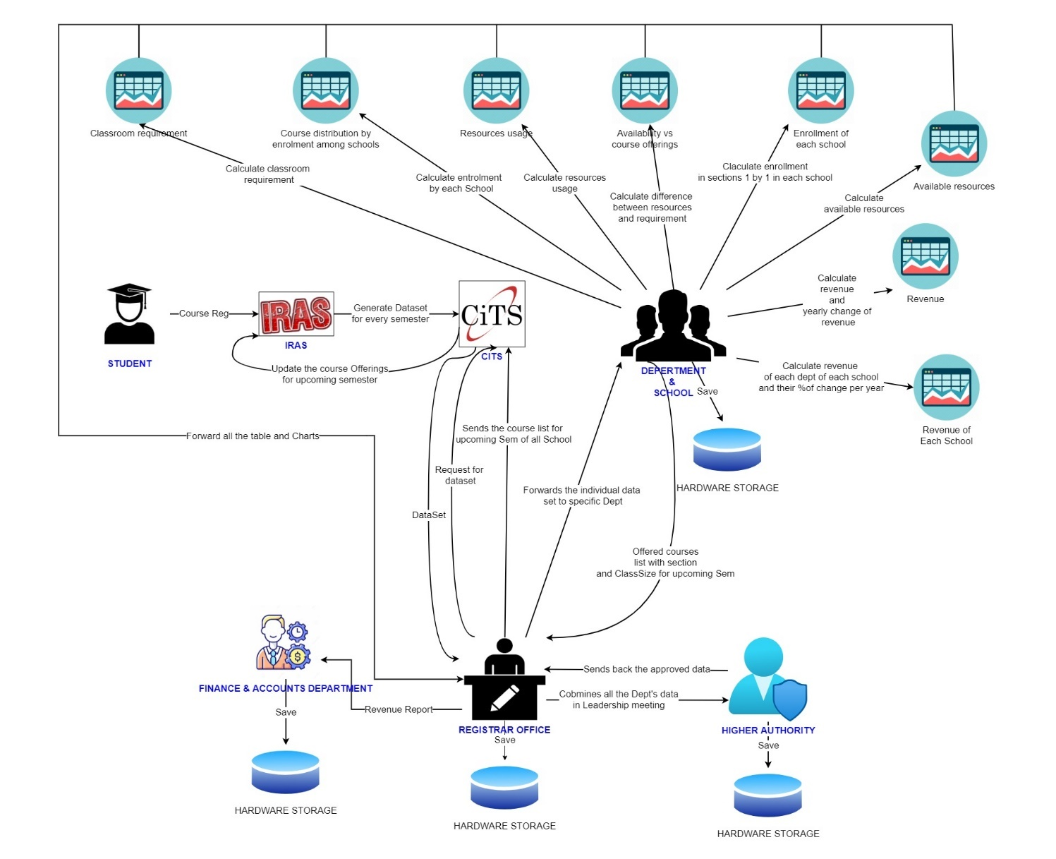

Figure : Rich Picture of Existing System

The Rich Picture Analysis shows us that we have the following types of stakeholders:

1. Department & School
2. Registrar’s office
3. Higher Authority: VC/ Pro-VC/ Board of Trustees
4. CITS

We can also identify four separate storage systems or facilities, namely:

1. The Department and School Storage
2. The Registrar’s Office Storage
3. Higher Authority’s storage

## B. SIX ELEMENTS ANALYSIS - EXISTING BUSINESS SYSTEM

The Six Elements Analysis provides a detailed description of the role of each element in each process. It is clear from the table below that Human entities dominate all key functions of this system. The existing system, for example, is substantially reliant on manually processed and managed hardcopy databases. As a result, before the Human parts can fulfill their end of the bargain in the process, there is a large amount of waiting between interdependent operations.

|  |  |  |  |  |  |  |
| --- | --- | --- | --- | --- | --- | --- |
| **Process** | **System Rules** | | | | | |
| **Human** | **Non-Computing hardware** | **Computing hardware** | **Software** | **Database** | **Network and communication** |
| **1. Datasheet**  **Distribution** | **CITS:**  1. Collects the generated dataset for every semester from IRAS.  2. Sends the generated dataset to the register’s office  3. Updates the course offerings for upcoming semester according to the information provided by register’s office  **Registrar’s office:**  1. Dataset for specific departments are forwarded accordingly to the respected department heads and revenue report is sent to the finance and accounts department  2. The manually calculated charts and tables from the departments along with the offered courses list as well as section and class size offerings for upcoming semester are received by register’s office  3. Combines all the received data then sends and waits for approval from higher authority.  4. Sends CITS the course list for upcoming semester of all school based on the approved data from higher authority  **Head of department:**  Sends offered courses list with section and class size for upcoming semester to the register's office.  **Higher Authority:**  Verifies all the combined data and sends the approved data to the register’s office | **Pen and paper:**  1. Is used for writing down important notes specific to departments.  2. Intermediate ideas may be written down. | **Computer / Laptop:**  1. Is used to make soft copies of the dataset as well as extra copies for later use.  **Printer:**  1. Used for printing out hardcopies of the dataset.  **Networking Devices (Router, Switch, Bridge, Hub):**  Used to access the Internet. | **Microsoft excel:**  1. It is used by the head of the departments as well as finance and accounts department to map all the calculations related to student enrollment and revenue.  2. To generate charts, MS excel is also used. | **Hardware storage:**  1. Is used for saving datasets in all the local computers associated with departments and higher authorities. | **Internet & Email:**  1. Internet and email is used to communicate between the register's office and all the departments along with CITS and higher authority.  2. All stakeholders may discuss important topics via email.  **Others:**  1. Phone’s or physical means may be used to communicate about related topics and outcomes between the stakeholders. |
| **2. Enrollment wise course distribution analysis** | **School (Team from school):**  1.Each school takes the tally sheet.  2. Count the number of sections with respect to the number of students starting from 1 going to the largest with an increment of 1  3. Calculates the total number of sections with respect to the enrollment range.  4. Every school sends the total calculation with respect to the enrolled range to the registrar’s office.  **Registrar’s office:**  1. Receives the calculated tables ( in excel file) with respect to the enrolled range from individual schools.  2. Calculates the total sections of all the schools with respect to enrolled range.  3. Creates line charts for the total sections of all the schools with respect to enrolled range.  4. Creates bar charts based on the total enrolled range for every school. | **Pen and Paper:**  1. To note down the necessary information if needed.  2. Used for any hard copy of the charts and tables if needed.  **Calculator:** For calculating all the data. | **Computer / Laptop:**  1. Users will use the device to access and view the data.  2. Storing the necessary information of softcopies such as the excel file.  **Printer:** Print the relevant documents.  **Networking Devices (Router, Switch, Bridge, Hub):**  Used to access the Internet. | **Microsoft office:**  1.Generate tables and manage them in MS Excel.  **Web Browser:**  To send and receive mails about important details and documents. | **Hardware Storage:**  Stores the information of the table on enrollment wise course distribution. | **Internet:**  Use the internet to access IRASv1 and Gmail. |
| **3. Revenue Analysis** | **Department Team:**  1. Team from Each Dept. Collects the revenue Data from the Tally sheets  2. Starts to Calculate annual revenue data  3. Initially open the Excel software and Load the required revenue data  4. In order to calculate the annual % change in revenue , we need to set a formula to find the total revenue of the departments.  5. Now set another formula to calculate the % change in revenue (e.g autumn 2009 to autumn 2010).  6. Now, the revenue data sheet prepared by each team of the departments is sent to the team of School  **School (A Team from School):**  1. The Revenue data sheet prepared by each team of department is received by a team from School.  2. Now the team of school will combine the revenue data sheet into one using Excel.  3. After combining all the revenue data semester wise .  4. Now, add all the semester wise revenue data to get the total sum of all departments (school e.g SETS).  5. Now set a formula to calculate the annual % change in revenue of the school (e.g autumn 2009 to autumn 2010).  6. The final revenue data that has been prepared will be sent to the higher authority for further analysis.  **Registrar’s office/ Higher Authority:**  Receives the calculated excel sheets from each school. | **Pen and Paper:**  1. To note down the necessary information if needed.  2. Used for any hard copy of the charts and tables if needed.  **Calculator:** For calculating all the data | **Computer:**  1. Department/CITS/Higher authority use computers to make soft copies of calculation, charts, tables data  2. All related data is searched and stored using a computer.  **Printer:**  1. To print out hard copies of the generated dataset.  **Networking Devices (Router, Switch, Bridge, Hub):**  Used to access the Internet. | **MS Excel:**  All related information is stored and calculated and all charts and tables are generated. | **Hardware storage:**  Used By Department/CITS/Finance Accounts/Higher authority to store data.  **File Cabinet:** Used by Department/CITS/Finance & Accounts**/**Higher authority to maintain the necessarycourse related documents in hard copy. | **Internet & Email:**  Used it to send mail to the Stakeholders to discuss information regarding courses list/capacity. |
| **4. Resources analysis** | *a. Usage of the resources:*  **School (A team from school):**  1. From the total number of enrolled students divide that value with the number of all sections for that school. This will generate Avg Enroll of a school in a semester.  2. Finding subtraction of Avg room and avg enrollment will give a difference of avg unused resources by each school in a semester.  3. To get %of unused resources divide the difference value with Avg room value then multiply by 100.  4. Send the calculated analysis of a school to the reg office.  **Registrar Office:**  1. A central team combines all the school’s resources usage analysis tables in Excel file in right format.  2. The team calculates overall semester’s resources usage by all of the schools by using formulas in Excel file.  *b. IUB available resources analysis:*  **Registrar Office:**  1. Calculate the available capacity of IUB based on class size and available class.  2.Using Class size* IUB resource formula a Central team finds the capacity table by class size as well as total available resource.  3. Then the team analyzes 6 slots or 7 slots per day capacity.  4. The team calculates the free% of capacity depending on 6/7 slots/day class allocation.  *c. Availability and course offering comparison:*  **Registrar Office:**  1. The Central team calculates a comparison table based on class size, IUB resources vs offered courses in a semester.  2. The central team calculates the difference based on class size between available classroom and needed classroom in a semester.  3. Generate the charts for Resource Utilization in different semester(s) using Excel charts. | **Pen and Paper:**  1. To note down the necessary information if needed.  2. Used for any hard copy of the data. | **Computer/Laptop:**  1. Department/ Registrar Office/ Higher authority use computers to make soft copies of data  2. All related data is searched and stored using a computer.  **Printer:**  To print out hard copies of the generated dataset.  **Networking Devices (Router, Switch, Bridge, Hub):**  Used to access the Internet.  **Calculator:** For calculating all the data | **MS Excel:**  All related information is stored and managed. | **Hardware storage:**  Used by Department Heads /Registrar Office/Higher authority to store data.  **File Cabinet:**  By Department Heads /Registrar Office/Higher authority to maintain the necessary course related documents in hard copy. | **Internet & Email:**  Used it to send mail to the stakeholders to discuss information regarding courses list. |
| **5. Classroom requirement analysis** | **Registrar’s office :**  1. A central team with respect to the total sections of all the schools based on the enrolled range, calculates the total number of slots required per day in excel sheet using the formula.  2. Sends the excel file to School for confirmation of distribution of classrooms per class size range on per slot.  3. Receives confirmation from each individual school.  3. Create pie charts showing percentage distribution of the classrooms per class size range based on per slot.  **School(Team from School):**  1. Receives the excel file containing slots per day based on class size range.  2. Checks if the slots calculated can be accepted or not.  3.After checking it sends the final excel sheet to the registrar’s office. | **Paper & pen:**  1. Need to take important notes for example during meetings. | **Computer / Laptop:**  1. Users will use the device to access and view the data and use excel to design the table.  2.Storing the necessary information as softcopies such as charts and tables on classroom requirement summary.  **Printer:** Print the relevant documents.  **Networking Devices (Router, Switch, Bridge, Hub):**  Used to access the Internet. | **Microsoft office:**  1.Make reports using MS Word.  2. Generate tables and manage them in MS Excel.  **Web**  **Browser:**  To send mails about important details and  documents. | **Hardware Storage:**  Stores the information on classroom requirement summary. | **Internet:**  Use the internet to access IRASv1 and Gmail. |
| **6. Accumulate school-based analysis** | **School(Team from School):**  1. All the respective teams of each school sends the calculated table based on their school to the registrar office. The calculated tables include:  i. Classroom requirement calculation  ii. Calculation of enrollment by each school  iii. Resource usage calculation  iv. Calculation of differences between resources and requirements.  v. Calculation of enrollment in sections 1 by 1 in each school  vi. Resource availability calculation.  vii. Calculation of school wise revenue and yearly change of revenue.  viii. Calculation of each department of each school along with % change per year.  **2.** **Central Team:**  1. Accumulates all the calculated tables of each school that was provided by the schools and places accordingly to the respected tables in an excel sheet. The tables here include:  i. Revenue of IUB  ii. Revenue in Engineering School.  iii. Enrollment wise course distribution among the schools.  iv. Usage of the resources  v. Classroom requirement as per course offering  vi. Breakdown of number of courses of each school table.  2. Calculates some of the accumulated tables. The calculations include:  i. The total revenue of all the schools in a certain semester. It is calculated by summing each of the schools revenue of a certain semester  ii. The annual percentage change of revenue.  iii. The total revenue of engineering schools along with the percentage change annually.  iv. The total enrollment among the schools is based on size.  v. The total resource usage of a semester among all the schools including average enrollment,average room capacity, difference between them and unused resource percentage.  vi. Total enrollment of all the schools of a semester based on incrimination of 1 to the largest number of students. Also the end total.  vii. Total sections needed for a certain range of capacity of a semester also the total sections for all capacities.  viii. Required classrooms for a given number of slots per day for a certain semester also the total number of classrooms for all capacities.  2. Generates charts on excel based on the accumulated data. The charts include:  i. Class size requirement pie chart  ii. Bar and line chart of class size distribution  iii. Resource utilization bar chart .  iv. Line chart for Revenue Trend of the schools  vii. Area chart on Revenue Distribution among the schools  viii. line and bar chart on IUB Revenue and Change %  ix. Line chart on Department wise revenue in SETS.  x. Area chart on Revenue of SETS. | **Pen and Paper:**  1. To note down the necessary information if needed.  2. Used for any hard copy of the data. | **Computer/Laptop:**  1. Department/ Registrar Office/ Higher authority use computers to make soft copies of data  2. All related data is searched and stored using a computer.  **Printer:**  To print out hard copies of the generated dataset.  **Networking Devices (Router, Switch, Bridge, Hub):**  Used to access the Internet.  **Calculator:** For calculating all the data | **MS Excel:**  All related information is stored and managed. | **Hardware storage:**  Used by Department Heads /Registrar Office/Higher authority to store data.  **File Cabinet:**  By Department Heads /Registrar Office/Higher authority to maintain the necessary course related documents in hard copy. | **Internet & Email:**  Used it to send mail to the stakeholders to discuss information regarding courses list. |

## C. PROCESS MODEL – EXISTING BUSINESS SYSTEM

BPMN stands for Business Process Model and Notation, which is a graphical depiction of business processes in a business process model. Each of the business processes outlined in the preceding section is dissected using business process model diagrams. Each figure depicts the many stakeholders engaged in the processes, their interactions, and the decisions that each of them must make.

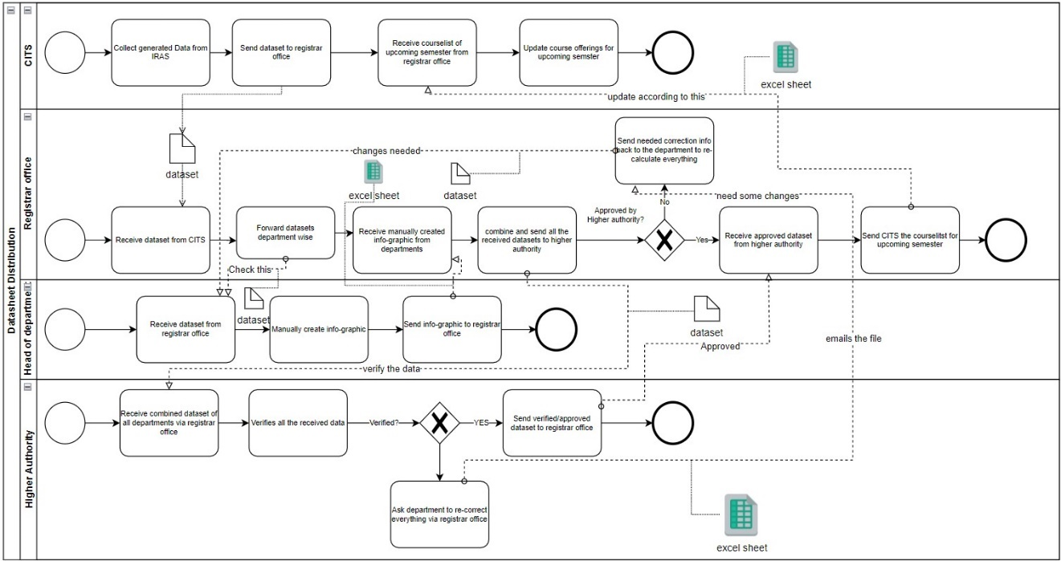

Figure : Datasheet Distribution

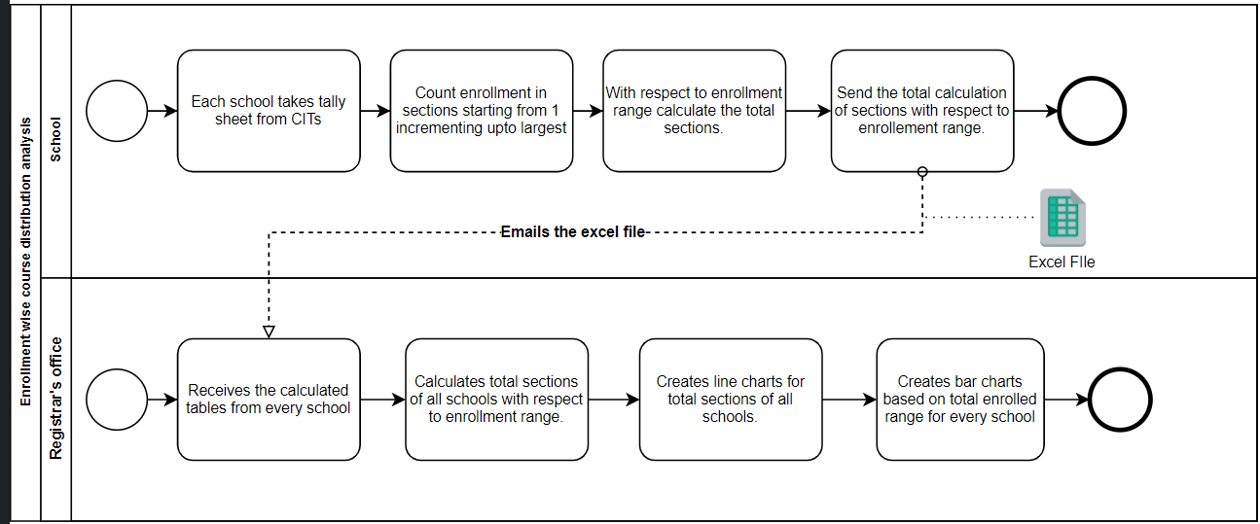

Figure : Enrollment wise course distribution analysis

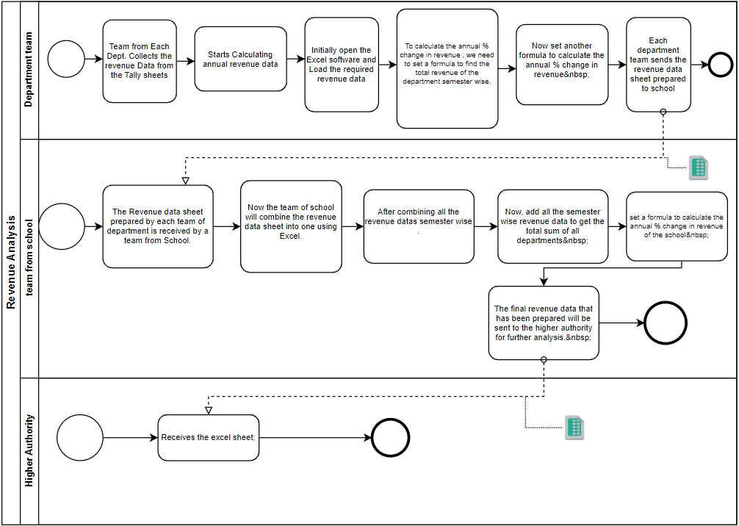

Figure : Revenue analysis.

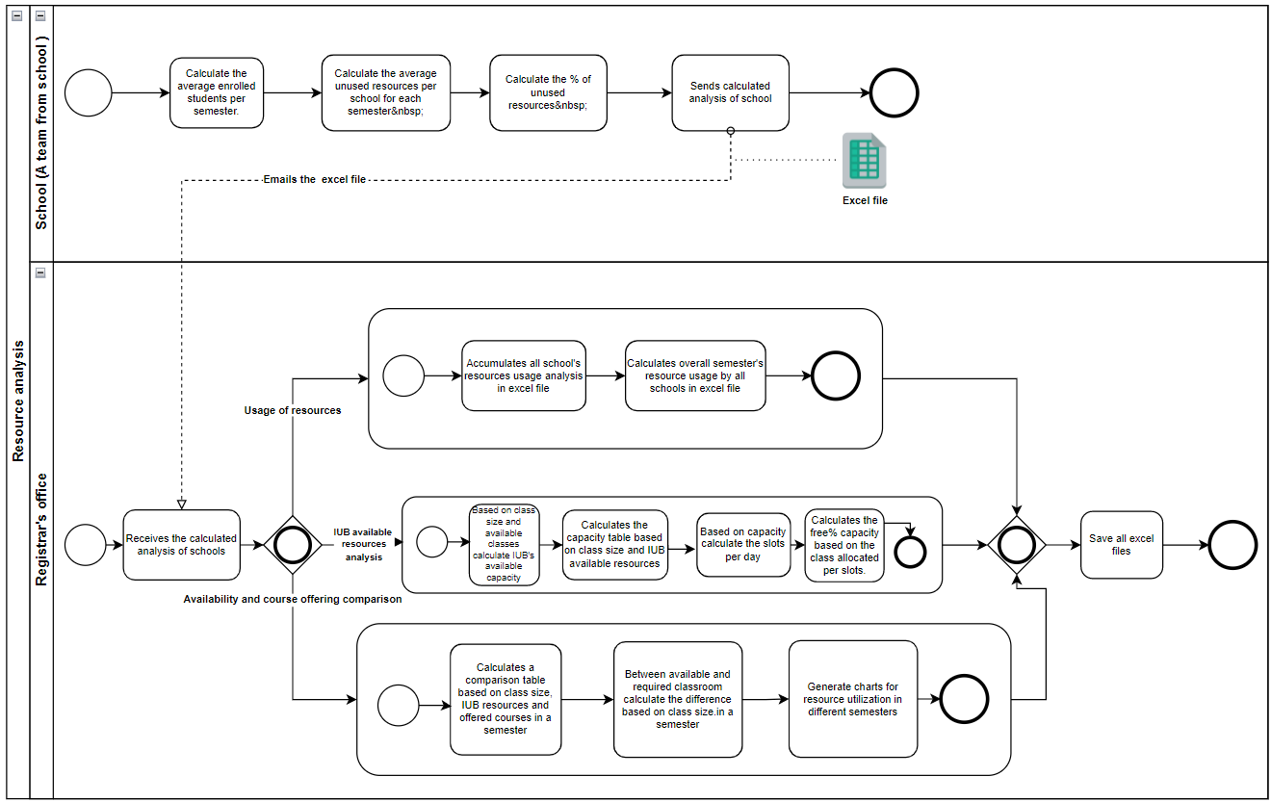

Figure : Resources analysis

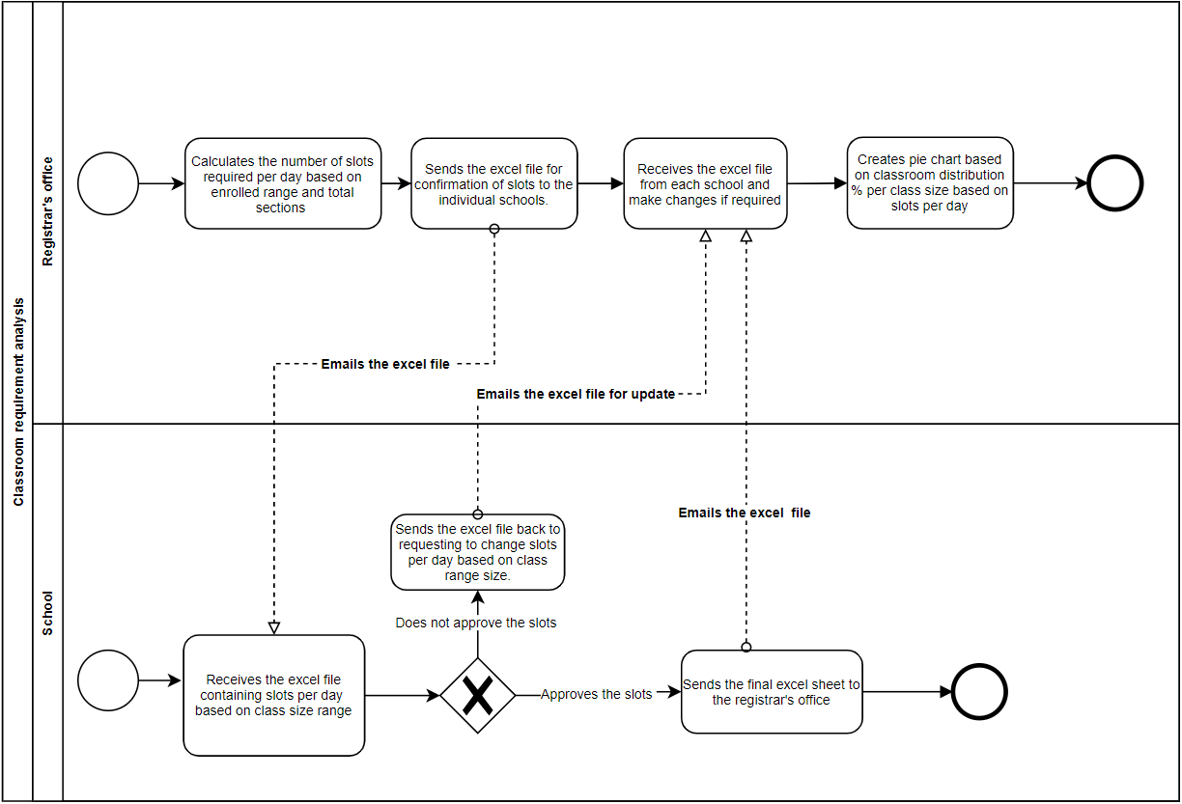

Figure : Classroom requirement analysis

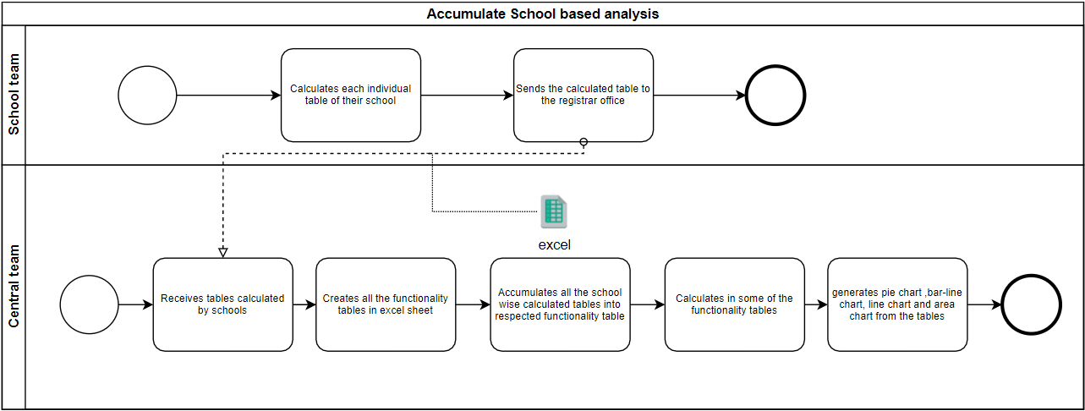

Figure : Accumulate School based analysis.

## D. PROBLEM ANALYSIS – EXISTING BUSINESS SYSTEM

The deficiencies in each process were found using the Six Elements Analysis of the existing systems. The analysis column of this table contains a recurring pattern. The facilitation of a private online platform looks to benefit the system in a variety of ways.

|  |  |  |  |  |
| --- | --- | --- | --- | --- |
| **Process Name** | **Stakeholders** | **Concerns(Problems)** | **Analysis (Reason of the Problems)** | **Proposed Solution** |
| **Datasheet distribution.** | 1. CITS  2. Registrar Office  3. Department  4. School  5. Higher Authority | 1. Requires manual distribution of all the files  2. Data redundancy and variability  3. Time Consuming  4. Human error  5. Decentralized | The datasheet generated from IRAS needs to be distributed among the stakeholders to manually calculate their parts in different analyses. As there is no central system that will do all analysis irrespective of the department or school. In the current system each dept needs to do their part then with that each school needs to do their part finally a team needs to combine all, which is time consuming as well as there is huge possibility of data redundancy and inconsistency . | We proposed a system where there’s no need for distribution. The system will work as a central system. |
| **Enrollment wise course distribution analysis.** | 1. School  2. Registrar’s Office | 1. Time consuming  2. Human error  3. Data redundancy and variability  4. Involves manual calculations  5. Decentralized | Every school needs to calculate their course distribution part manually and then send them to the Registrar's office for combining all schools' analysis, which is a long process since one process needs to wait for another process to finish its task. As there is no central system that will do all the analysis irrespective of the schools the more human involvement the more human error can happen which is time consuming as well as there is huge possibility of data redundancy and inconsistency. | The system itself calculates and generates tables and charts according to the user request from the dataset it is provided. So no need for manual calculation or hassle for school or dept-wise data combination. |
| **Revenue analysis.** | 1. Department  2. School  3. Registrar’s office  4. Higher Authority | 1. Involves manual calculations.  2. Human error  3. Time consuming  4. Data redundancy and variability  5. Incorrect data values | Every department and school needs to calculate their revenue analysis part manually and then send them to the Registrar's office for combining all schools' analysis sheets. As there is no central system that will do all the analysis irrespective of the schools, this is time consuming as well as there is huge possibility of data redundancy and inconsistency. The datasheet also consist of some inexact values of data. The more human involvement the more human error can happen. | The system itself calculates and generates tables and charts according to the user request from the dataset it is provided. So no need for manual calculation or hassle for school or dept data combined. |
| **Resources analysis.** | 1. School  2. Registrar’s office | 1. Involves huge data compilation  2. Time consuming  3. Data redundancy and variability  4. Human error  5. Decentralized  6. Incorrect data values | Analyze the resources usage by different schools individually. Overall usage needs to combine all school data which is a long process. As there is no central system that will do all the analysis irrespective of the schools, this is time consuming as well as there is huge possibility of data redundancy and inconsistency. The datasheet also consist of some invalid values of data. The more human involvement the more human error can happen. | The system itself calculates and generates tables and charts according to the user request from the dataset it is provided. So no need for manual calculation or hassle for school or dept data combined. |
| **Classroom requirement analysis.** | 1. Registrar’s office | 1. Involves manual calculations  2. Time consuming  3. Human error  4. Decentralized | A central team from all schools manually calculate the classroom analysis and then generate charts. For every semester doing this task manually takes a lot of time. As there is no central system that will do all the analysis irrespective of the schools. The more human involvement the more human error can happen. | The system itself calculates and generates tables and charts according to the user request from the dataset it is provided. Hence no need for manual calculation or hassle for school or dept data combined. |
| **Accumulate school-based analysis.** | 1. School  2. Registrar’s office | 1. Involves huge data compilation  2. Data redundancy and variability  3. Human error  4. Time consuming  5. Decentralized | All the calculated excel sheets from all schools need to be combined and then overall university analysis is done. Since every dept, school does their calculation individually and saves that to their hardware storage a single data can be stored in multiple storage. Since there is no central system that will do all the analysis irrespective of the schools. The more human involvement the more human error can happen. Different dept/ schools may save or generate data in different formats which may lead to difficulties while combining; moreover, if one calculation error is found anywhere or a data needs to be changed anywhere it needs to be changed or corrected everywhere which is a huge problem of the current system. | The system itself calculates and generates tables and charts according to the user request from the dataset it is provided. Hence no need for manual calculation or hassle for school or dept data combined. Also all data is now in one place so no need to worry about data redundancy or inconsistency. |

## E. RICH PICTURE - PROPOSED SYSTEM

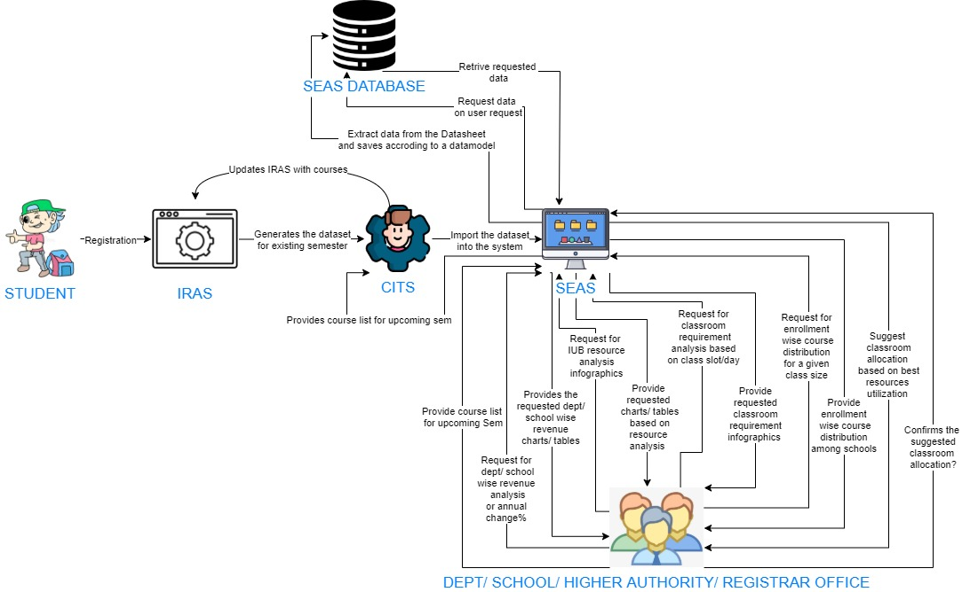

Figure : Rich Picture for Proposed System

## F. SIX ELEMENTS ANALYSIS – PROPOSED SYSTEM

|  |  |  |  |  |  |  |
| --- | --- | --- | --- | --- | --- | --- |
| **Process** | **System Rules** | | | | | |
| **Human** | **Non-Computing hardware** | **Computing hardware** | **Software** | **Database** | **Network and communication** |
| **1.**  **Import dataset into the system** | **CITS:**  1. Retrieves the generated dataset from IRAS.  2. Upload the Dataset into the System. | **Pen and Paper:**  1. To note down the necessary information if needed.  2. Used for any hard copy of the data | **Computer:**  1. CITS uses computers to make soft copies of data.  2. All related data is searched and stored using a computer**.**  **Printer:**  To print out hard copies of the generated dataset**.**  **Networking Devices (Router, Switch, Bridge, Hub):**  Used to access the Internet. | **MS Excel:**  All related information is stored.  **IRAS:**  Generates the dataset for the existing semester  **SEAS:**  Importthe dataset into the system for further analysis. | **Hardware storage:**  To store data.  **SEAS Database:**  The Imported Data will be stored into the System’s Database. | **Internet :**  Internet is used to import data from IRAS and store it into the System. |
| **2. View System generated Resources analysis.** | **Department/School /High Authority/ Registrar Office:**  1. Logs into the System using UserID and password.  2. Select user type from User Type selection drop box.  *(i) Usage of the resources:*  3. From the navigation menu select the option for Usage of the resources.  4. Select school from school selection checkbox, Semester from selection checkbox.  5. Click generate to view the usage table by selected school in the selected semester.  6. This will also show the overall usage by the selected semester(s).  *(ii)IUB available resources:*  3. From the navigation menu select the option for IUB available resources.  4. Selecting this will show a summary table of available resources based on the capacity of all university rooms and the quantity of such rooms.  *(iii) Availability and course offering comparison:*  3. From the navigation menu select the option for Availability and course offering comparison.  4. Select type of infographics (i.e. chart/ table), select semester from semester selection checkbox.  5. Clicking generate will show the selected chart/ table that is comparing the number of available classrooms per classroom size to the number necessary. |  | **Computer/ Laptop:**  Users will need a computer to access SEAS.  **Printer:**  To print the infographic report if needed.  **Networking Devices (Router, Switch, Bridge, Hub):**  Used to access the Internet. | **SEAS:**  The system will generate the requested infographic.  **Web Browser:**  To access SEAS. | **SEAS Database:**  Contains all data.  **Hardware storage:**  To save the system generated infographic. | **Internet:**  It is required to access the system. |
| **3. View system generated Revenue Analysis.** | **Department/School /High Authority/ Registrar Office:**  1. Logs into the System using UserID and password.  2. Select user type from User Type selection drop box.  *(i)Revenue of IUB:*  3. From the navigation menu select the option for Revenue of IUB.  4. Select the type of infographic from the selection checkbox.  5. Select the school(s) from the school selection checkbox, Select Annual change% if the user wants to view the percentage of annual revenue change by a school.  6. Click generate to view the selected infographic.  *(ii)Revenue Of a School:*  3. From the navigation menu select the option for Revenue Of a School.  4. Select the type of infographic from the selection checkbox.  5. Select the school from dropdown box.  6. Select the dept(s) from the available dept checkbox.  7.Click generate to view selected infographic of Department wise revenue in selected school.  *(iii) Revenue by a Dept:*  3. From the navigation menu select the option for Revenue Of a School.  4. To view dept wise infographic Check Mark the Dept wise View option.  5. Select the Dept.  6.Clicking generate will show the Revenue trend as well as change% in revenue chart by that dept for all semester. |  | **Computer/ Laptop:**  User will need a computer to access SEAS.  **Printer:**  To print the infographic report if needed.  **Networking Devices (Router, Switch, Bridge, Hub):**  Used to access the Internet. | **SEAS:**  The system will generate the requested infographic.  **Web Browser:**  To access SEAS. | **SEAS Database:**  Contains all data.  **Hardware storage:**  To save the system generated infographic. | **Internet:**  It is required to access the system. |
| **4.View Classroom requirement analysis.** | **Department/School /High Authority/ Registrar Office:**  1. Logs into the System using UserID and password.  2. Select user type from User Type selection drop box.  3. From the navigation menu select the option for Classroom requirement charts and tables.  4. Select the type of infographic from the selection checkbox.  5. Select the class size range from the dropdown box, select semester from semester selection checkbox, select class slot/day from selection checkbox.  6.Click generate to view the selected infographic. |  | **Computer/ Laptop:**  Users will need a computer to access SEAS.  **Printer:**  To print the infographic report if needed.  **Networking Devices (Router, Switch, Bridge, Hub):**  Used to access the Internet. | **SEAS:**  The Software will propose course capacity based on previous semester data and resources.  **Web Browser:**  1.Access important information from other sources such as the IUB webpage to view details about any courses.  2. To send mails about important  details and documents.  3. To access SEAS. | **SEAS Database:**  1. To provide required data based on user request.  2.SEAS retrieves data from the database, when needed.  **Hardware storage:**  To save the system generated infographic. | **Internet:**  Use the internet to log in for accessing into SEAS. |
| **5.View enrollment wise course distribution analysis.** | **Department/School /High Authority/ Registrar Office:**  1. Logs into the System using UserID and password.  2. Select user type from User Type selection drop box.  *(i) Enrollment wise course distribution:*  3. From the navigation menu select the option for enrollment wise course distribution.  4. Select the type of infographic from the selection checkbox.  5. Select the class size range from the dropdown box, select school from school selection checkbox, select semester from semester selection checkbox.  6.Click generate to view the selected infographic.  *(ii)View number of enrollments in sections 1 by 1:*  3. From the navigation menu select the option for View number of enrollments in sections 1 by 1.  4. Select the school from the school selection checkbox, select semester from semester selection checkbox.  5.Click generate to view the table. |  | **Computer/ Laptop:**  Users will need a computer to access SEAS.  **Printer:**  To print the infographic report if needed.  **Networking Devices (Router, Switch, Bridge, Hub):**  Used to access the Internet. | **SEAS:**  The Software will propose course capacity based on previous semester data and resources.  **Web Browser:**  1.Access important information from other sources such as the IUB webpage to view details about any courses.  2. To send mails about important  details and documents.  3. To access SEAS. | **SEAS Database:**  1. To provide required data based on user request.  2.SEAS retrieves data from the database, when needed.  **Hardware storage:**  To save the system generated infographic. | **Internet:**  Use the internet to log in for accessing into SEAS. |

## G. PROCESS MODEL - PROPOSED SYSTEM

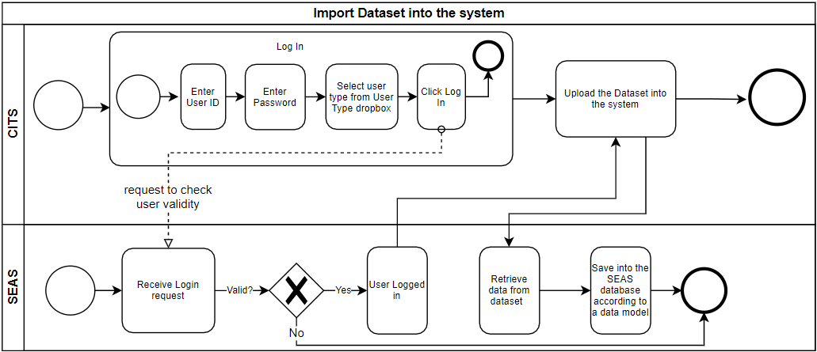

Figure : Import dataset into the system.

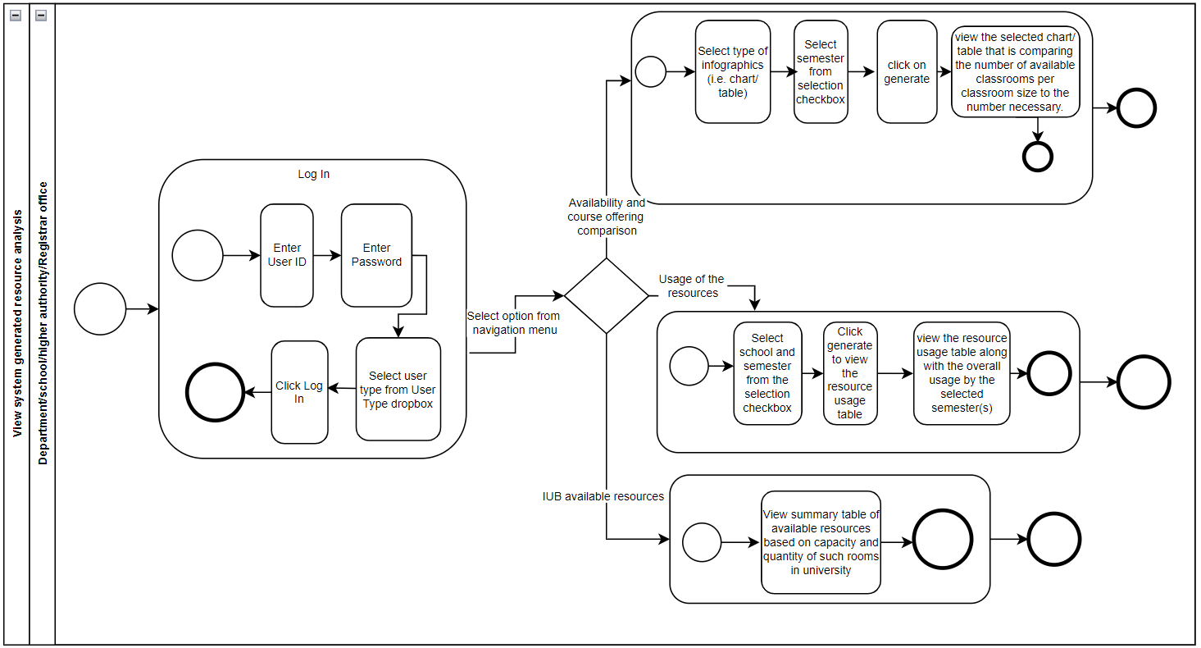

Figure : View System generated resource analysis.

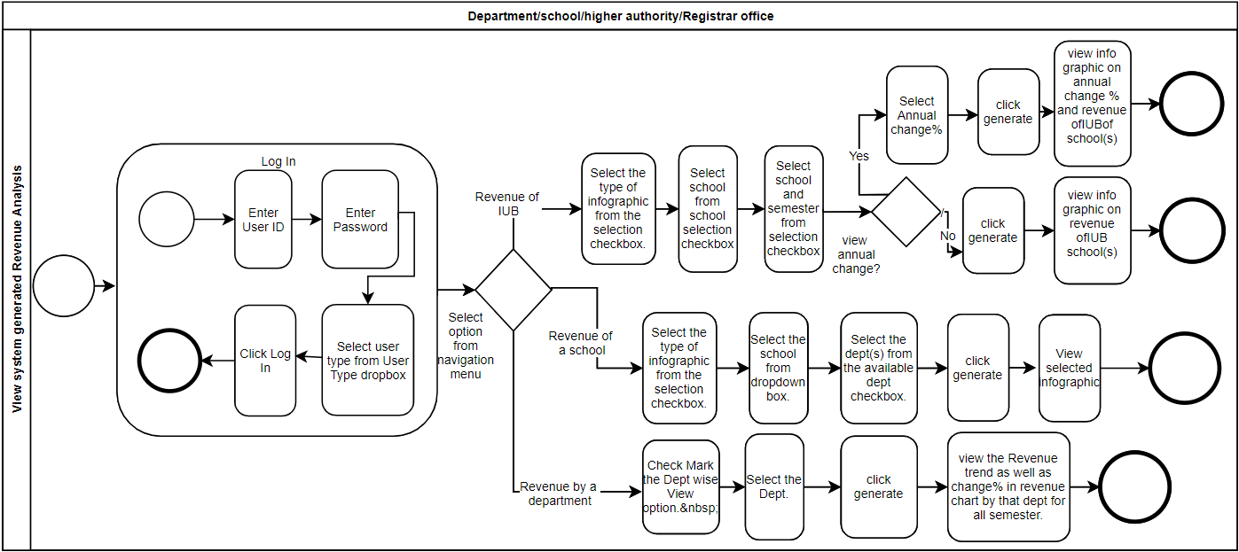

Figure : View system generated Revenue Analysis.

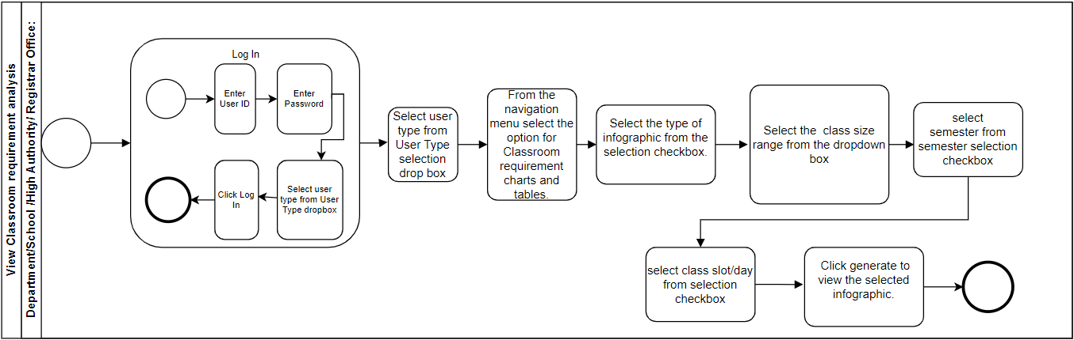

Figure : View Classroom requirement analysis.

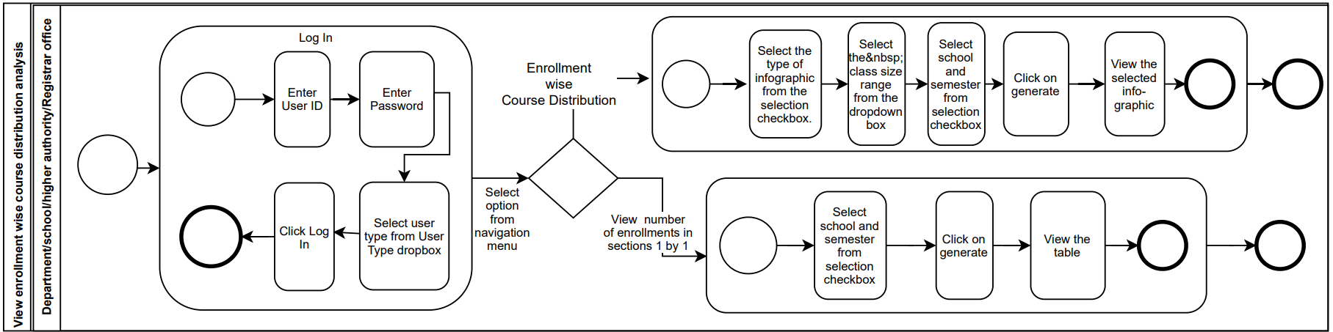

Figure : View enrollment wise course distribution analysis.

# chapter 3- Logical System Design

## a. business rule

1. A Faculty has a FacultyID, FacultyName.
2. A Department has a DeptID, DeptName. Each Faculty must belong to a Department. A Department must have one or more Faculties.
3. A School has a SchoolTitle, SchoolName. A Department must belong to exactly one School. A School must have one or more Departments. Each Faculty must belong to a School. A School must have one or more Faculties.
4. A Course has a CourseID, CourseName, CreditHour. Each Course must belong to exactly one Department. A Department must offer at least one Course.
5. A Course may have many co-offered courses as well as a course may be offered with multiple courses.
6. Each Course must have one or more Sections, where the existence of a Section depends on the existence of that Course. The SectionID can be uniquely identified using SectionNum, Semester and Year. A Section also includes SectionCapacity, SectionEnrolled, Blocked status of that section, FreeSpace which is always calculated based on SectionCapacity and SectionEnrolled, and TotalStudentCredit which is calculated by multiplying SectionEnrolled and CourseCredit. A Section must belong to exactly one course.
7. Each Section must be taken by a Faculty. A Faculty may take many sections.
8. A Room has a RoomID, RoomCapacity. Each Room may contain many Sections. A Section’s class must be held in one Room where the StartTime, EndTime and Day of the class must be recorded.

## B. entity relationship diagram

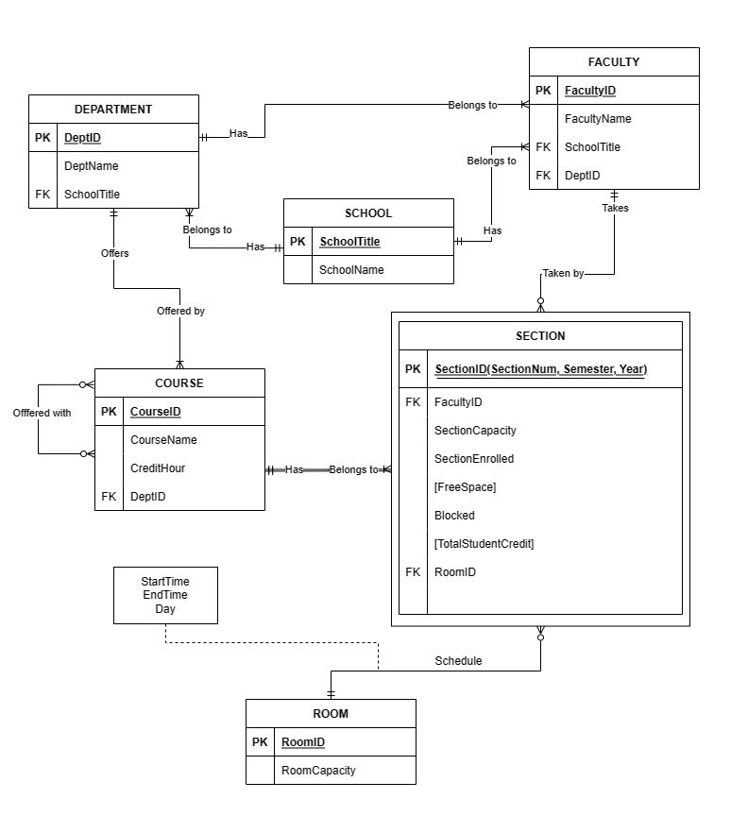

Figure : Entity Relationship Diagram

## c. ENTITY RELATIONSHIP DIAGRAM TO RELATIONAL SCHEMA:

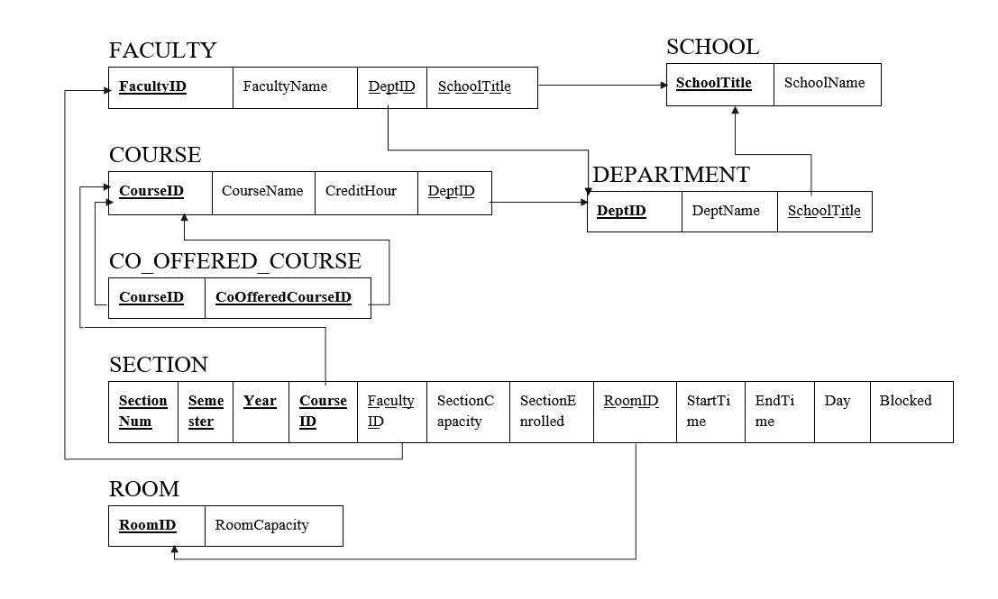

Figure : Relational Schema

## D. Normalization

Functional Dependency:

|  |  |  |
| --- | --- | --- |
| FacultyID | → | FacultyName, DeptID, SchoolTitle |
| SchoolTitle | → | SchoolName |
| CourseID | → | CourseName, CreditHour, DeptID, CoOfferedCourseID |
| CoOfferedCourseID | → | CourseID |
| DeptID | → | DeptName, SchoolTitle |
| SectionNum, Semester, Year, CourseID | → | FacultyID, SectionCapacity, SectionEnrolled, RoomID, StartTime, EndTime, Day, Blocked |
| RoomID | → | RoomCapacity |

***1NF:***

T1:

|  |  |  |  |  |  |  |  |  |  |
| --- | --- | --- | --- | --- | --- | --- | --- | --- | --- |
| **SectionNum** | **Semester** | **Year** | **CourseID** | FacultyID | FacultyName | DeptID | DeptName | SchoolTitle | SchoolName |

|  |  |  |  |  |  |  |  |  |  |  |
| --- | --- | --- | --- | --- | --- | --- | --- | --- | --- | --- |
| SectionCapacity | SectionEnrolled | RoomID | RoomCapacity | StartTime | EndTime | Day | Blocked | CourseName | CreditHour | CoOfferedCourseID |

***2NF:***

T11:

|  |  |  |  |  |  |  |  |
| --- | --- | --- | --- | --- | --- | --- | --- |
| **CourseID** | CourseName | CreditHour | CoOfferdCourseID | DeptID | DeptName | SchoolTitle | SchoolName |

T12:

|  |  |  |  |  |  |  |  |  |  |
| --- | --- | --- | --- | --- | --- | --- | --- | --- | --- |
| **SectionNum** | **Semester** | **Year** | **CourseID** | FacultyID | FacultyName | SectionCapacity | SectionEnrolled | RoomID | RoomCapacity |

|  |  |  |  |
| --- | --- | --- | --- |
| StartTime | EndTime | Day | Blocked |

***3NF:***

T113

|  |  |  |
| --- | --- | --- |
| **FacultyID** | FacultyName | DeptID |

T111

T112

|  |  |  |
| --- | --- | --- |
| **DeptID** | DeptName | SchoolTitle |

|  |  |
| --- | --- |
| **SchoolTitle** | SchoolName |

T114

|  |  |  |  |  |
| --- | --- | --- | --- | --- |
| **CourseID** | CourseName | CreditHour | DeptID | CoOfferedCourseID |

T115

|  |  |  |  |  |  |  |  |  |
| --- | --- | --- | --- | --- | --- | --- | --- | --- |
| **SectionNum** | **Semester** | **Year** | **CourseID** | FacultyID | SectionCapacity | SectionEnrolled | RoomID | RoomCapacity |

|  |  |  |  |
| --- | --- | --- | --- |
| StartTime | EndTime | Day | Blocked |

T116

|  |  |
| --- | --- |
| **RoomID** | RoomCapacity |

***BCNF****:*

T113

|  |  |  |
| --- | --- | --- |
| **FacultyID** | FacultyName | DeptID |

T111

T112

|  |  |  |
| --- | --- | --- |
| **DeptID** | DeptName | SchoolTitle |

|  |  |
| --- | --- |
| **SchoolTitle** | SchoolName |

T1142

|  |  |
| --- | --- |
| **CourseID** | **CoOfferedCourseID** |

T1141

|  |  |  |  |
| --- | --- | --- | --- |
| **CourseID** | CourseName | CreditHour | DeptID |

T115

|  |  |  |  |  |  |  |  |  |
| --- | --- | --- | --- | --- | --- | --- | --- | --- |
| **SectionNum** | **Semester** | **Year** | **CourseID** | FacultyID | SectionCapacity | SectionEnrolled | RoomID | RoomCapacity |

|  |  |  |  |
| --- | --- | --- | --- |
| StartTime | EndTime | Day | Blocked |

T116

|  |  |
| --- | --- |
| **RoomID** | RoomCapacity |

## e. Data Dictionary

tblschool:

|  |  |  |  |
| --- | --- | --- | --- |
| **Name** | **Data Type** | **Size** | **Remark** |
| cSchoolTitle | VARCHAR | 5 | This is the primary key of School. E.g: “SETS”. This can’t be null. |
| cSchoolName | VARCHAR | 50 | This is the name of the school. E.g: “School of Engineering, Technology & Science”. This can’t be null. |

tbldepartment:

|  |  |  |  |
| --- | --- | --- | --- |
| **Name** | **Data Type** | **Size** | **Remark** |
| cDeptID | VARCHAR | 6 | This is the primary key for Department table  E.g: “CSE”. This can’t be null. |
| cDeptName | VARCHAR | 50 | This is the name of the department.  E.g: “Computer Science and Engineering”. This can’t be null. |
| cSchoolTitle | VARCHAR | 5 | This is the foreign key from School table. E.g: “SETS”. This can’t be null. |

tblfaculty:

|  |  |  |  |
| --- | --- | --- | --- |
| **Name** | **Data Type** | **Size** | **Remark** |
| nFacultyID | INTEGER |  | This is the primary key for Faculty table. E.g: “4434”. This can’t be null. |
| cFacultyName | VARCHAR | 50 | This is the name of the Faculty. E.g: “Sadita Ahmed”. This must not be nullable. |
| cDeptID | VARCHAR | 6 | This is the foreign key from Department table  E.g: “CSE”. This can’t be null. |

tblcourse:

|  |  |  |  |
| --- | --- | --- | --- |
| **Name** | **Data Type** | **Size** | **Remark** |
| cCourseID | VARCHAR | 7 | This is the Primary Key for the Course table. E.g: “CSE303”. This can’t be null. |
| cCourseName | VARCHAR | 100 | This is the name of the Course. E.g: “Database Management”. This can’t be null. |
| nCreditHour | INTEGER |  | This is the number of credits for the Course. E.g: “3”. This can’t be null. |
| cDeptID | VARCHAR | 6 | This is the foreign key from Department table. E.g: “CSE”. This can’t be null. |

tblcoofferedcourse:

|  |  |  |  |
| --- | --- | --- | --- |
| **Name** | **Data Type** | **Size** | **Remark** |
| cCourseID | VARCHAR | 7 | This is the Primary Key for the coofferedcourse table and a foreign key from Course Table E.g: “CSE303”. This can’t be null. |
| cCoOfferdCourseID | VARCHAR | 7 | This is the Primary Key for the coofferedcourse table and a foreign key from Course Table. E.g: “CEN401”. This can’t be null. |

tblroom:

|  |  |  |  |
| --- | --- | --- | --- |
| **Name** | **Data Type** | **Size** | **Remark** |
| cRoomID | VARCHAR | 9 | This is the Primary Key for the Room table. E.g: “BC4017A-S”. This can’t be null. |
| nRoomCapacity | INTEGER |  | This is the capacity of the room. E.g: “50”. This can’t be null. |

tblsection:

|  |  |  |  |
| --- | --- | --- | --- |
| **Name** | **Data Type** | **Size** | **Remark** |
| nSectionNum | INTEGER |  | This is the primary key for Section table. E.g: “2”. This can’t be null. |
| cSemester | VARCHAR | 6 | This is the primary key for Section table.  E.g: “Autumn”. This can’t be null. |
| dYear | YEAR | “YYYY” | This is the primary key for Section table.  E.g: “2020”. This can’t be null. |
| cCourseID | VARCHAR | 7 | This is the part of the primary key for Section table and a foreign key from Course table. E.g: “CSE303”. This can’t be null. |
| nFacultyID | INTEGER |  | This is the foreign key from Faculty table. E.g: “4434” |
| nSectionCapacity | INTEGER |  | This is the total capacity of the section.  E.g: “30” |
| nSectionEnrolled | INTEGER |  | This is the number of students enrolled in a section. E.g: “29” |
| dStartTime | TIME | “hh:mm:ss” | This is the time when a section starts.  E.g: “11:00” |
| dEndtime | TIME | “hh:mm:ss” | This is the time when a section ends.  E.g: “17:00” |
| cDay | VARCHAR | 10 | This is the day of the Section’s class. E.g: “ST” |
| cRoomID | VARCHAR | 9 | This is the foreign key from Room table.  E.g: “BC4017A-S” |
| cBlocked | VARCHAR | 3 | This shows if the section is blocked or not. E.g: “B-“ |

# Chapter 4- PHYSICAL SYSTEM DESIGN:

## A. INPUT FORM:

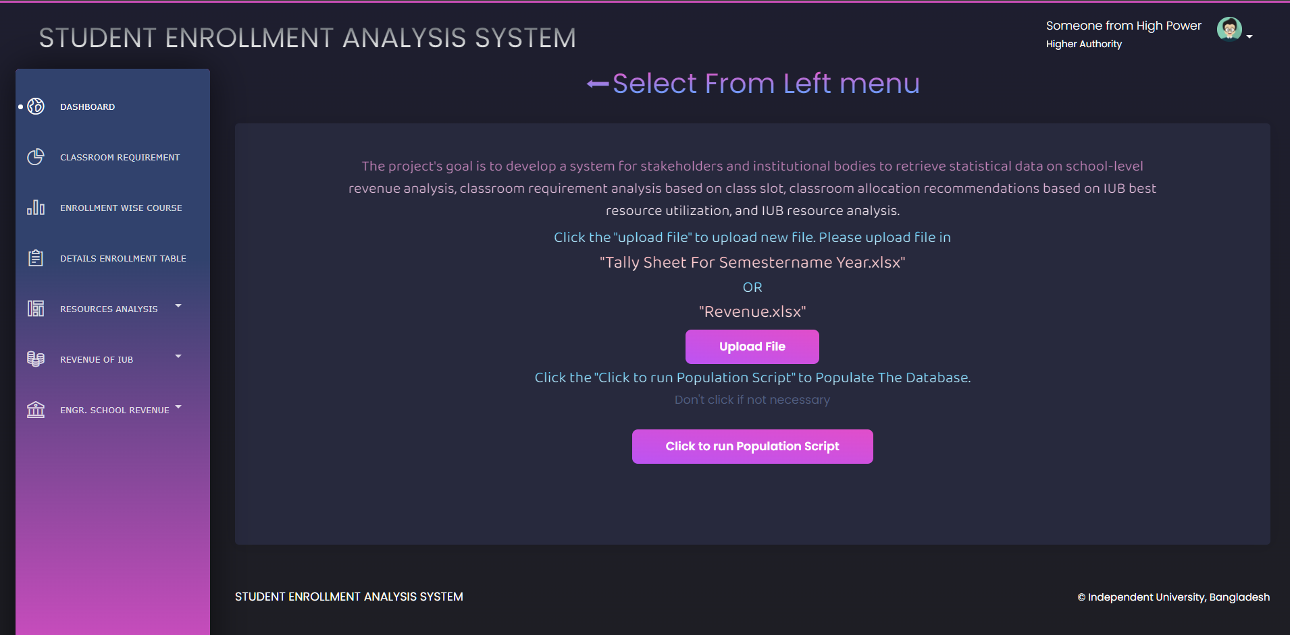

def uploadfunc(request):

    if request.method == 'POST':

        form = uploadfileform(request.POST or None, request.FILES or None)

        if form.is_valid():

            form.save()

    else:

        form = uploadfileform()

    return render(request, 'home.html', {'form': form})

def runpopulationscript(request):

    path = str(BASE_DIR)+"//Scripts//PopulationScript.py"

    filepath = str(BASE_DIR)+"//media//Resources"

    filenameslist = next(walk(filepath), (None, None, []))[2]

    listToStr = ' '.join([str(elem) for elem in filenameslist])

    run([sys.executable, path, listToStr, filepath], shell=True)

    return render(request, 'home.html', {'data1': "DB updated"})

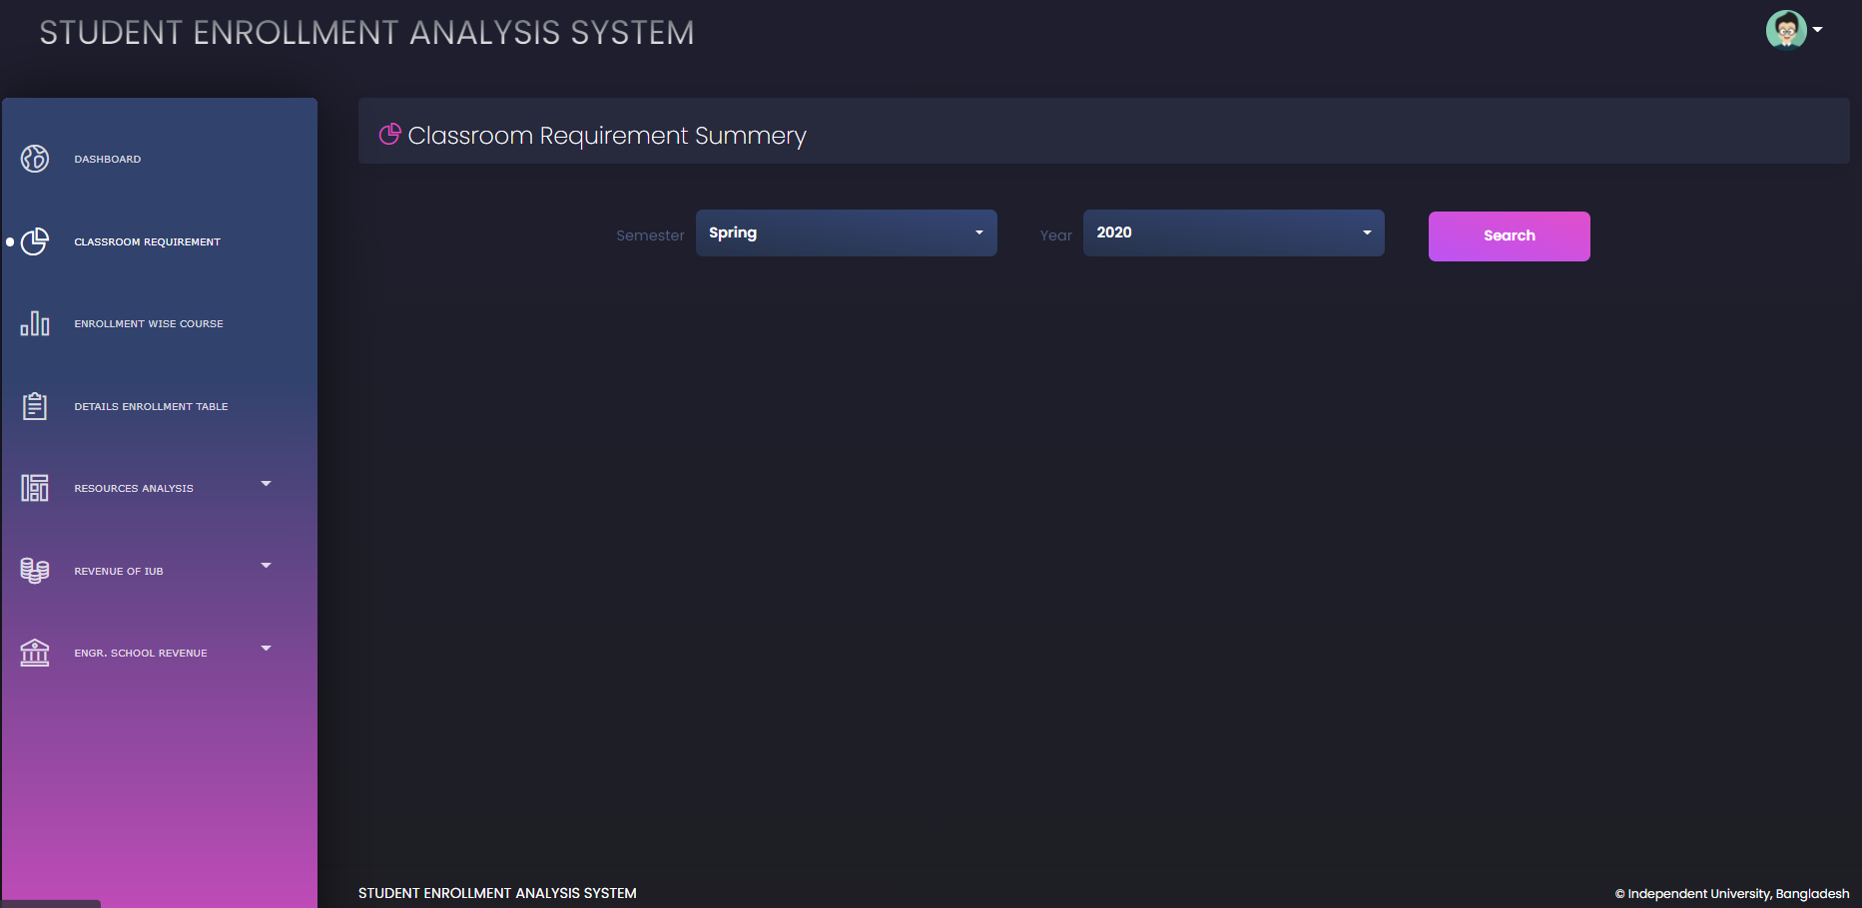

def view_classroom_requirement_course_offer(request):

    if request.method == 'POST':

        #semester = semesterlist[int(request.POST.get('sem'))]

        #year = yearlist[int(request.POST.get('year'))]

        lbl = ['1-10', '11-20', '21-30', '31-35',

               '36-40', '41-50', '51-55', '56-65']

        semester = request.POST.get('sem')

        year = request.POST.get('year')

        sections = classroom_requirement_course_offer(semester, year)

        selectedsem = semester+' '+year

        table = []

        class6 = []

        #print(sections)

        sumsections = sum(sections)

        for i in sections:

            class6.append("{:.2f}".format(i/12))

        #print(class6)

        sumcls6 = "{:.2f}".format(sum([float(i) for i in class6]))

        class7 = []

        for i in sections:

            class7.append("{:.2f}".format(i/14))

        #print(class7)

        sumcls7 = "{:.2f}".format(sum([float(i) for i in class7]))

        for i in range(len(lbl)):

            col1 = lbl[i]

            col2 = sections[i]

            col3 = class6[i]

            col4 = class7[i]

            table.append([col1, col2, col3, col4])

        table.append(['Total', sumsections, sumcls6, sumcls7])

        print(class6)

        str1 = semester+" "+str(year)

        return render(request, 'classsize.html', {

            'semesters': semesterlist,

            'years': yearlist,

            'class6': class6,

            'class7': class7,

            'sections': sections,

            'seme': str1,

            'table': table,

            'selectedsem': selectedsem,

            'search': 0,

            'segment': 'cls_req',

        })

    else:

        return render(request, 'classsize.html', {

            'semesters': semesterlist,

            'years': yearlist,

            'segment': 'cls_req',

            'search': 1,

        })

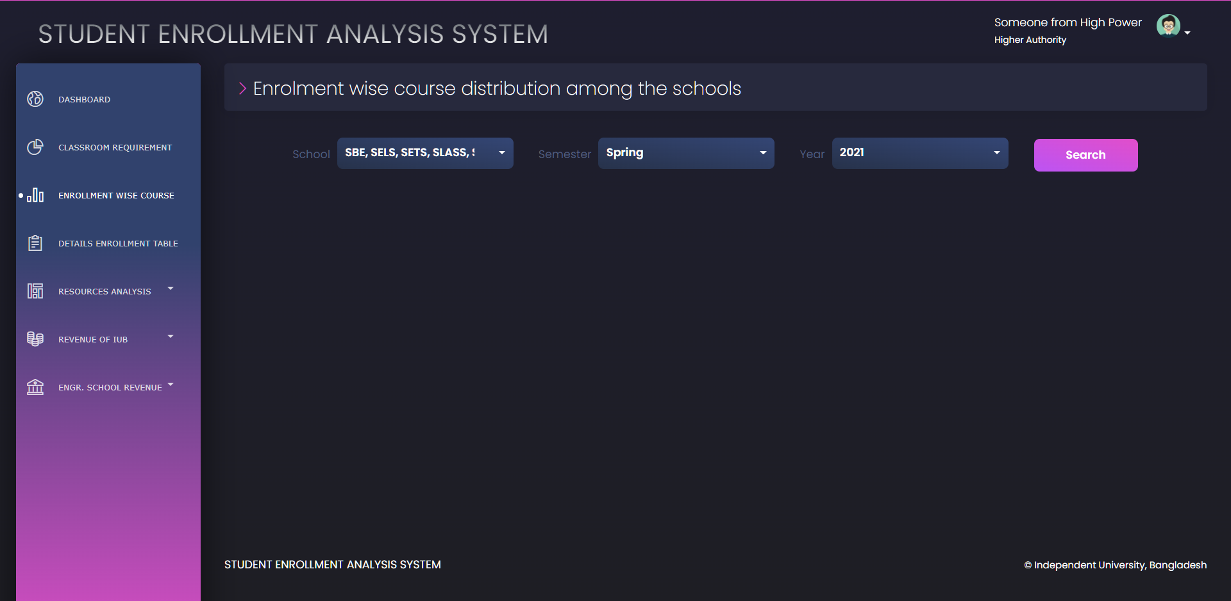

def view_enrolment_course_school(request):

    if request.method == 'POST':

        l = ['1-10', '11-20', '21-30', '31-35', '36-40',

             '41-50', '51-55', '56-60', '60+']

        school = request.POST.getlist('scl')

        semester = request.POST.get('sem')

        year = request.POST.get('year')

        selectedsem = semester+' '+year

        rowsize = len(school)+2

        enrollment = []

        labels = []

        for i in school:

            enrollment.append(enrollment_wise_course_school(i, semester, year))

        for j in l:

            for i in school:

                labels.append(i+':'+j)

        #enrollment = [item for t in enrollment for item in t for item in item]

        list0 = []

        list1 = []

        list2 = []

        list3 = []

        list4 = []

        list5 = []

        list6 = []

        list7 = []

        list8 = []

        list9 = []

        list10 = []

        table = []

        for i in enrollment:

            e = [item for t in i for item in t]

            list0.append(e)

            list9.append(e[0])

            list1.append(e[1])

            list2.append(e[2])

            list3.append(e[3])

            list4.append(e[4])

            list5.append(e[5])

            list6.append(e[6])

            list7.append(e[7])

            list8.append(e[8])

        list10.append(sum(list9))

        list10.append(sum(list1))

        list10.append(sum(list2))

        list10.append(sum(list3))

        list10.append(sum(list4))

        list10.append(sum(list5))

        list10.append(sum(list6))

        list10.append(sum(list7))

        list10.append(sum(list8))

        temprow = []

        for i in range(len(l)):

            temprow = [row[i] for row in list0]

            temprow.append(list10[i])

            temprow.insert(0, l[i])

            table.append(temprow)  # make row wise

        list0.insert(0, list10)

        # table.append([row[0] for row in list0].insert(0,'Total'))#add total to end of the list

        print(table)

        return render(request, 'enrollmentwise.html', {

            'schools': schoolList,

            'selectedschool': school,

            'rowsize': rowsize,

            'selectedsem': selectedsem,

            'semesters': semesterlist,

            'years': yearlist,

            'table': table,

            'enrollment': list0,

            'labels': labels,

            'search': 0,

            'segment': 'enroll',

        })

    else:

        return render(request, 'enrollmentwise.html', {

            'schools': schoolList,

            'semesters': semesterlist,

            'years': yearlist,

            'segment': 'enroll',

            'search': 1,

        })

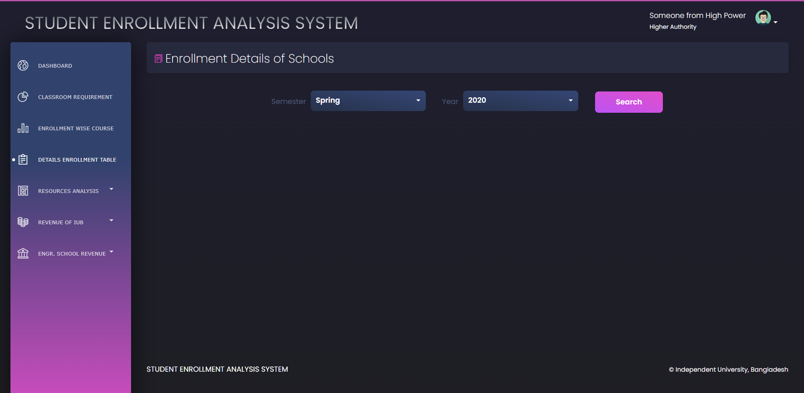

def view_enrolment_details(request):

    if request.method == 'POST':

        sem = request.POST.get('sem')

        year = request.POST.get('year')

        sbe = []

        sels = []

        sets = []

        slass = []

        spph = []

        sbe = details_enrollment('SBE', sem, year)

        sels = details_enrollment('SELS', sem, year)

        sets = details_enrollment('SETS', sem, year)

        slass = details_enrollment('SLASS', sem, year)

        spph = details_enrollment('SPPH', sem, year)

        selectedsem = sem+' '+year

        # print(sbe)

        # print(sels)

        m = []

        m.append(max(sbe, key=itemgetter(0))[0])

        m.append(max(sels, key=itemgetter(0))[0])

        m.append(max(sets, key=itemgetter(0))[0])

        m.append(max(slass, key=itemgetter(0))[0])

        m.append(max(spph, key=itemgetter(0))[0])

        maxenroll = max(m)+1

        sbe = [element for tupl in sbe for element in tupl]

        sels = [element for tupl in sels for element in tupl]

        sets = [element for tupl in sets for element in tupl]

        slass = [element for tupl in slass for element in tupl]

        spph = [element for tupl in spph for element in tupl]

        # Elements from list1 starting from 1 iterating by 2

        listOddsbe = sbe[1::2]

        # Elements from list1 starting from 0 iterating by 2

        listEvensbe = sbe[::2]

        listOddsels = sels[1::2]

        listEvensels = sels[::2]

        listOddsets = sets[1::2]

        listEvensets = sets[::2]

        listOddslass = slass[1::2]

        listEvenslass = slass[::2]

        listOddspph = spph[1::2]

        listEvenspph = spph[::2]

        for i in range(maxenroll):

            if i not in listEvensbe:

                listEvensbe.insert(i, i)

                listOddsbe.insert(i, 0)

        sumsbe = sum(listOddsbe)

        for i in range(maxenroll):

            if i not in listEvensels:

                listOddsels.insert(i, 0)

        sumsels = sum(listOddsels)

        for i in range(maxenroll):

            if i not in listEvensets:

                listOddsets.insert(i, 0)

        sumsets = sum(listOddsets)

        for i in range(maxenroll):

            if i not in listEvenslass:

                listOddslass.insert(i, 0)

        sumslass = sum(listOddslass)

        for i in range(maxenroll):

            if i not in listEvenspph:

                listOddspph.insert(i, 0)

        sumspph = sum(listOddspph)

        tabledata = []

        totalsum = []

        tabledata2 = []

        tabledata3 = []

        tabledata4 = []

        tabledata5 = []

        for i in range(maxenroll):

            a0 = listEvensbe[i]

            a1 = listOddsbe[i]

            a2 = listOddsels[i]

            a3 = listOddsets[i]

            a4 = listOddslass[i]

            a5 = listOddspph[i]

            a6 = a1+a2+a3+a4+a5

            totalsum.append(a6)

            tabledata.append([a0, a1, a2, a3, a4, a5, a6])

        tabledata.append(['Total', sumsbe, sumsels, sumsets,

                         sumslass, sumspph, sum(totalsum)])

        # print(sum(tabledata))

        return render(request, 'enrolmentdetails.html', {

            'semesters': semesterlist,

            'years': yearlist,

            'selectedsem': selectedsem,

            'selectedyear': year,

            'range': listEvensbe,

            'tabledata': tabledata,

            'search': 0,

            'segment': 'details',

        })

    else:

        return render(request, 'enrolmentdetails.html', {

            'semesters': semesterlist,

            'years': yearlist,

            'search': 1,

            'segment': 'details',

        })

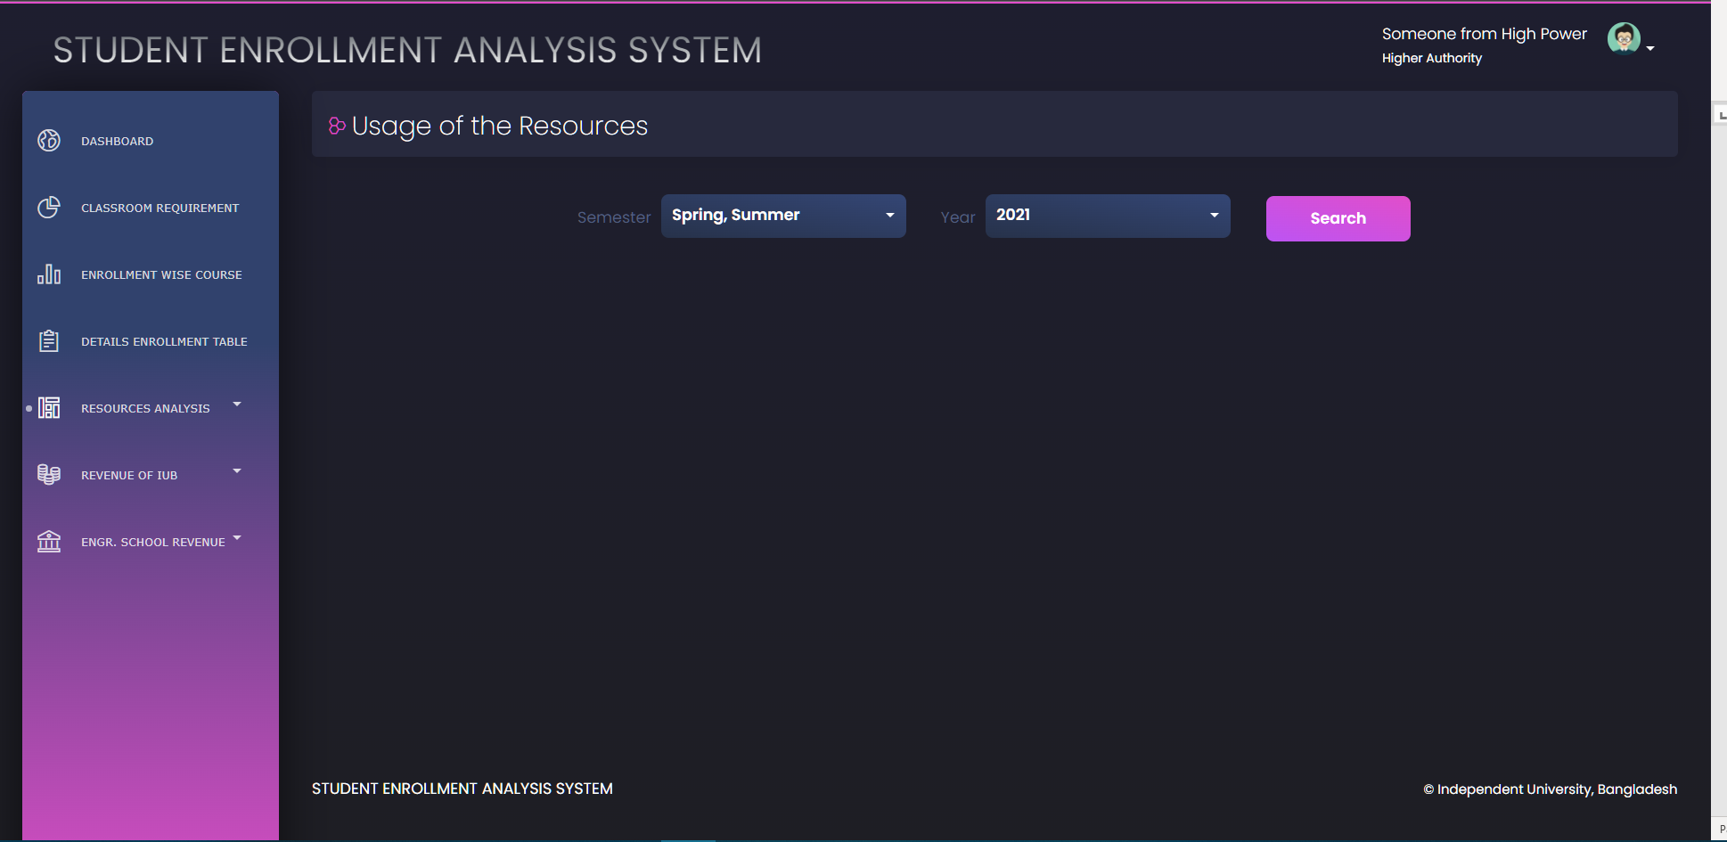

def view_usage_resource(request):

    if request.method == 'POST':

        sem = request.POST.getlist('sem')

        year = request.POST.get('year')

        table = []

        total = []

        table2=[]

        t2r1 = ['Average of ROOM_CAPACITY']

        t2r2 = ['Average of ENROLLED']

        t2r3 = ['Average of Unused Space']

        t2r4 = ['Unused Percent %']

        selectedsem='| '

        for i in sem:

            sbe = resources_usage('SBE', i, year)

            sels = resources_usage('SELS', i, year)

            sets = resources_usage('SETS', i, year)

            slass = resources_usage('SLASS', i, year)

            spph = resources_usage('SPPH', i, year)

            selectedsem+= i+' '+year+' | '

            # touple of touple to list

            sbe = [float("%.2f" % (element)) for tupl in sbe for element in tupl]

            # https://stackoverflow.com/questions/3204245/how-do-i-convert-a-tuple-of-tuples-to-a-one-dimensional-list-using-list-comprehe

            # https://stackoverflow.com/questions/455612/limiting-floats-to-two-decimal-points

            sels = [float("%.2f" % (element)) for tupl in sels for element in tupl]

            sets = [float("%.2f" % (element)) for tupl in sets for element in tupl]

            slass = [float("%.2f" % (element))for tupl in slass for element in tupl]

            spph = [float("%.2f" % (element)) for tupl in spph for element in tupl]

            totala = sbe[0]+sels[0]+sets[0]+slass[0]+spph[0]

            totalb = sbe[1]+sels[1]+sets[1]+slass[1]+spph[1]

            totalc = sbe[2]+sels[2]+sets[2]+slass[2]+spph[2]

            totald = sbe[3]+sels[3]+sets[3]+slass[3]+spph[3]

            totale = sbe[4]+sels[4]+sets[4]+slass[4]+spph[4]

            t2r1.append("%.2f" % (totalb/5))

            t2r2.append("%.2f" % (totalc/5))

            t2r3.append("%.2f" % (totald/5))

            t2r4.append("%.2f" % (totale/5))

            total.append([i, totala, "%.2f" % (totalb/5), "%.2f" %(totalc/5), "%.2f" % (totald/5), "%.2f" % (totale/5)])

            sbe.insert(0,'SBE')

            sels.insert(0, 'SELS')

            sets.insert(0,'SETS')

            slass.insert(0,'SLASS')

            spph.insert(0,'SPPH')

            total.append(sbe)

            total.append(sels)

            total.append(sets)

            total.append(slass)

            total.append(spph)

        print(total)

        table+=total

        table2=[t2r1]+[t2r2]+[t2r3]+[t2r4]

        total=[]

        print(table2)

        return render(request, 'resourceusage.html', {

            'semesters': semesterlist,

            'years': yearlist,

            'table': table,

            'table2':table2,

            'selectedsem': selectedsem,

            'selectedyear':year,

            'semfort2':sem,

            'rowsize':len(sem)+1,

            'search': 0,

            'segment': 'usage',

        })

    else:

        return render(request, 'resourceusage.html', {

            'semesters': semesterlist,

            'years': yearlist,

            'search': 1,

            'segment': 'usage',

        })

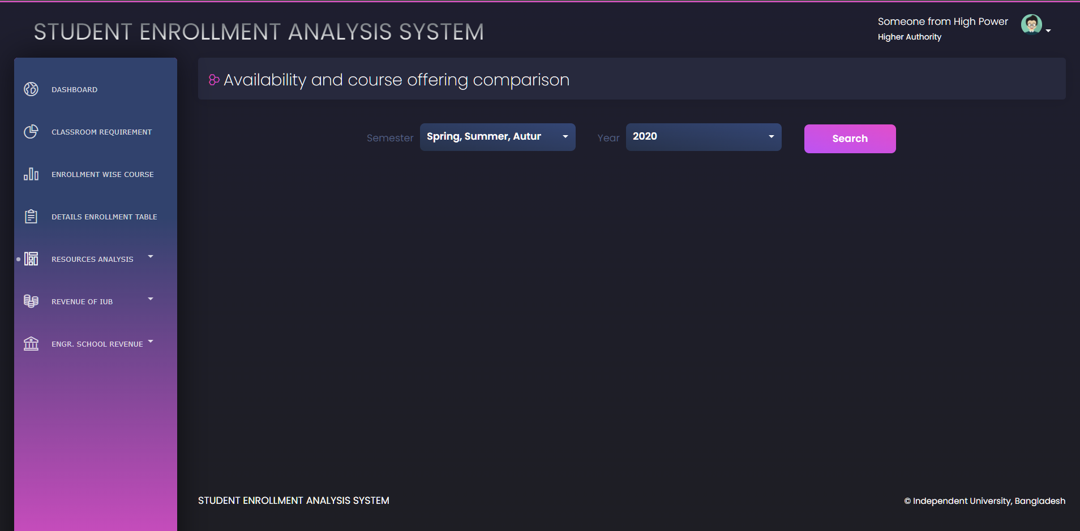

def view_availabilityvscourse_offer(request):

    if request.method == 'POST':

        semester = request.POST.getlist('sem')

        year = request.POST.get('year')

        roomsize = roomsizelist()

        roomsize = [element for tupl in roomsize for element in tupl]

        class6 = []

        for i in semester:

            sections = classroom_requirement_course_offer(i, year)

            class6temp=[]

            for j in sections:

                class6temp.append(float("{:.2f}".format(j/12)))

            class6.append(class6temp)

        # print(class6)

        # sumcls6 = "{:.2f}".format(sum([float(i) for i in class6]))

        listOddsize = roomsize[::2]

        listEvensize = roomsize[1::2] #ulta ache. odd ->even, even-> odd e ase.

        class6offered=[]

        for j in range(0,len(semester)):

            a=[]

            b=[]

            c=[]

            d=[]

            e=[]

            f=[]

            g=[]

            c6 = []

            r=class6[j][0]

            s=class6[j][1]

            t=class6[j][2]

            u=class6[j][3]

            v=class6[j][4]

            w=class6[j][5]

            x=class6[j][6]

            y=class6[j][7]

            k=0

            l=0

            for i in range(0,len(listOddsize)):

                if listOddsize[i] in range(1, 21):

                    # print(listOddsize[i])

                    # print(r+s)

                    a.append(r+s)

                if listOddsize[i] in range(21, 31):

                    # print(listOddsize[i])

                    # print(t)

                    b.append(t)

                if listOddsize[i] in range(31, 36):

                    # print(listOddsize[i])

                    # print(u)

                    c.append(u)

                if listOddsize[i] in range(36, 41):

                    # print(listOddsize[i])

                    # print(v)

                    d.append(v)

                if listOddsize[i] in range(41, 51):

                    # print(listOddsize[i])

                    # print(w)

                    e.append(w)

                if listOddsize[i] in range(51, 56):

                    # print(listOddsize[i])

                    # print(x)

                    f.append(x)

                if listOddsize[i] in range(56, 65):

                    # print(listOddsize[i])

                    # print(y)

                    g.append(y)

            c6=a+b+c+d+e+f+g

            if len(f)==0:

                listOddsize.append(54)

                listEvensize.append(0)

                c6.append(x)

            if len(g)==0:

                listOddsize.append(64)

                listEvensize.append(0)

                c6.append(y)

            #c6.insert(0,sum(c6))

            class6offered.append(c6)

            c6=[]

            a = []

            b = []

            c = []

            d = []

            e = []

            f = []

            g = []

        totalroom = listEvensize

        #totalroom.insert(0,sum(listEvensize))

        chartdata=[]

        chartlabel = listOddsize

        chartdata += class6offered #+[totalroom]

        print(class6offered)

        print(listEvensize)

        #table shuru->

        temptable=[]

        tablelabel=[]

        rowlentemp = len(listOddsize)

        tablelabel+=listOddsize

        tablelabel.append('Total')

        resource = listEvensize

        difference = []

        for i in range(0,len(semester)):

            for j in range(len(listEvensize)):

                difference.append(float("{:.2f}".format(listEvensize[j]-class6offered[i][j])))

        difference = [difference[i:i+rowlentemp]

                      for i in range(0, len(difference), rowlentemp)]

        temptable.append(resource)

        for i in range(0, len(semester)):

            temptable.append(class6offered[i])

            temptable.append(difference[i])

        table=np.transpose(temptable)# https://numpy.org/doc/stable/reference/generated/numpy.transpose.html

        total= np.sum(table, axis=0)#https://www.delftstack.com/howto/numpy/sum-of-columns-matrix-numpy/

        total = ["%.2f" % member for member in total]#https://stackoverflow.com/questions/2762058/format-all-elements-of-a-list

        table = np.append(table, [total], axis=0)#https://www.codegrepper.com/code-examples/python/add+row+to+numpy+2+dimension+arrayhttps://www.codegrepper.com/code-examples/python/add+row+to+numpy+2+dimension+array

        finaltable=np.c_[tablelabel,table]#https://moonbooks.org/Articles/How-to-add-a-new-column-in-a-table-using-python-and-numpy-/

        # # #https://stackoverflow.com/questions/12575421/convert-a-1d-array-to-a-2d-array-in-numpy

        # # differencematrix=np.reshape(difference,(-1, len(semester)))

        #print(finaltable)

        return render(request, 'availabilityvscourse.html', {

            'schools': schoolList,

            'semesters': semesterlist,

            'years': yearlist,

            'chartdata':chartdata,

            'chartlabel':chartlabel,

            'selectedsem': semester,

            'noofcols': 2+len(semester)*2,

            'resource': listEvensize,

            'table': finaltable,

            'search': 0,

            'segment': 'usage',

        })

    else:

        return render(request, 'availabilityvscourse.html', {

            'schools': schoolList,

            'semesters': semesterlist,

            'years': yearlist,

            'search': 1,

            'segment': 'usage',

        })

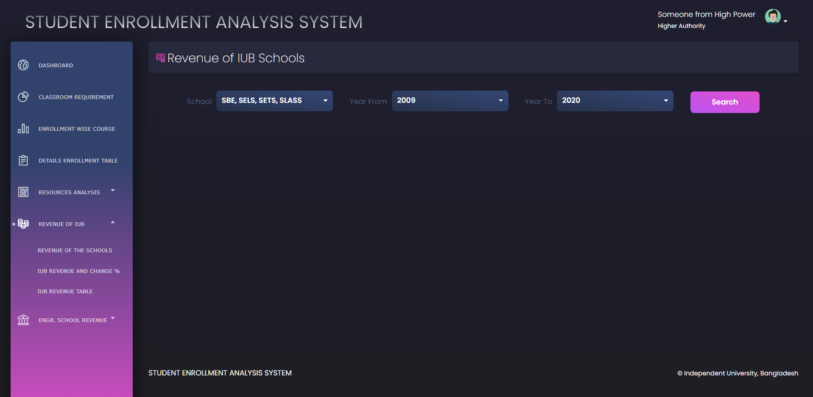

def view_revenue_of_iub(request):

    if request.method == 'POST':

        school = request.POST.getlist('scl')

        yearf = request.POST.get('year1')

        yeart = request.POST.get('year2')

        print(school, yearf, yeart)

        revenue = []

        for i in school:

            revenue.append(iub_revenue(yearf, yeart, i))

        # print(revenue)

        a = abs(int(yearf)-int(yeart))+1

        # print(type(a))

        list1 = []

        list2 = []

        list3 = []

        total = []

        for j in revenue:

            for i in j:

                list1.append(str(i[0])+i[1])

                list2.append(int(i[2]))

        list1 = list(dict.fromkeys(list1))

        list2 = [list2[i:i+a*3] for i in range(0, len(list2), a*3)]

        # print(list1)

        # print(list2)

        return render(request, 'revenueofiub.html', {

            'schools': schoolList,

            'yearfrom': yearlist,

            'yearto': yearlist,

            'selectedschool': school,

            'revenuesemyear': list1,

            'revenue': list2,

            'search': 0,

            'segment': 'rev',

        })

    else:

        return render(request, 'revenueofiub.html', {

            'schools': schoolList,

            'yearfrom': yearlist,

            'yearto': yearlist,

            'search': 1,

            'segment': 'rev',

        })

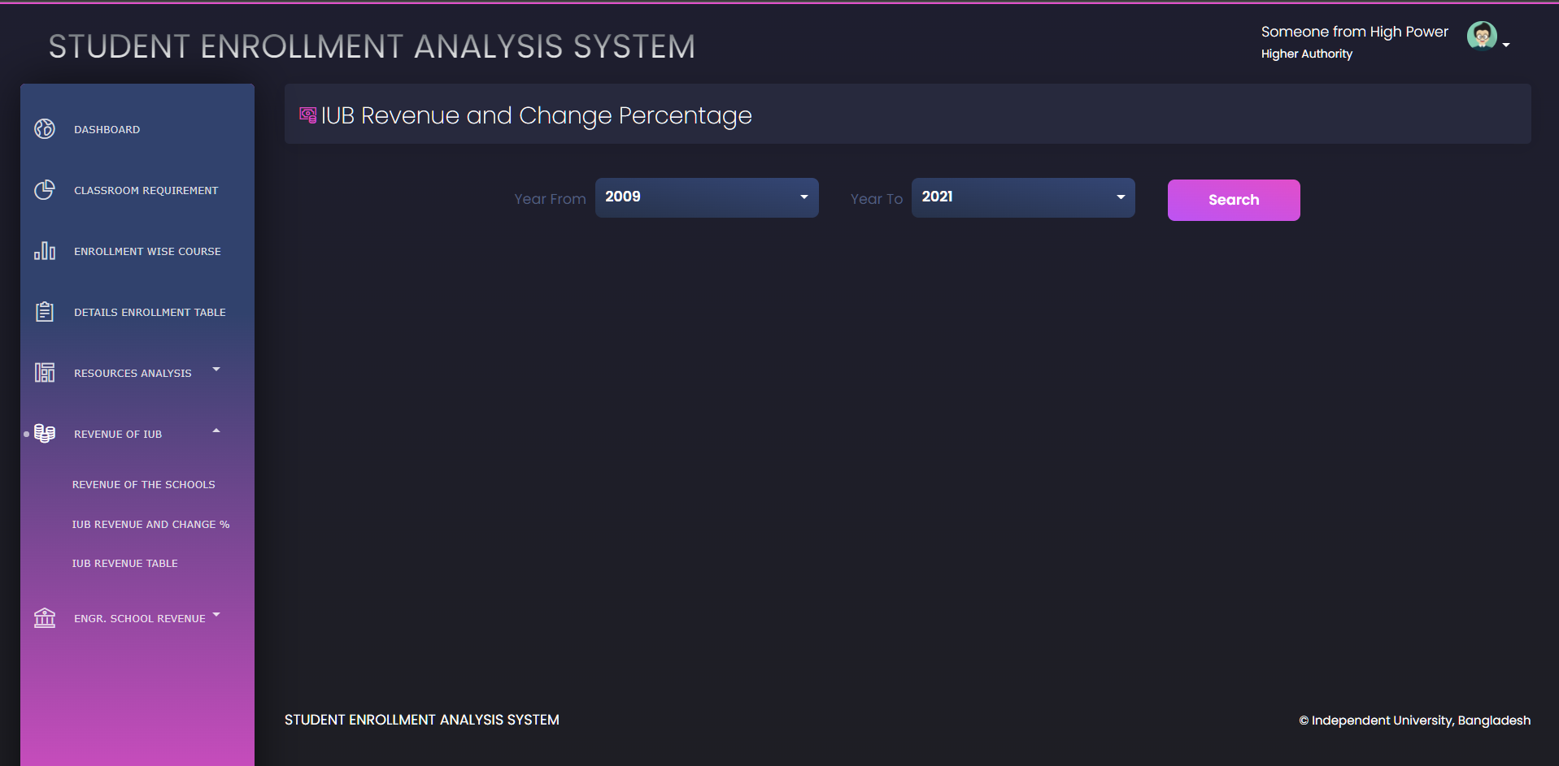

def view_rev_change(request):

    if request.method == 'POST':

        yearf = request.POST.get('year1')

        yeart = request.POST.get('year2')

        revenue = []

        revenue.append(iub_revenue_total(yearf, yeart))

        # print(revenue)

        y = abs(int(yearf)-int(yeart))+1

        # print(type(a))

        list1 = []

        list2 = []

        list3 = []

        list4 = []

        list5 = []

        list6 = []

        list7 = []

        list8 = []

        list9 = []

        list10 = []

        total = []

        for j in revenue:

            for i in j:

                list1.append(str(i[0])+i[1])

                list2.append(int(i[2]))

        list1 = list(dict.fromkeys(list1))

        total = list2

        list2 = [list2[i:i+3] for i in range(0, len(list2), 3)]

        print(total)

        for i in list2:

            list3.append(i[0])

            list4.append(i[1])

            list5.append(i[2])

        # print(list3)

        for i in list3:

            # if(list3.index(i)<len(list3)):

            if list3.index(i) != 0:

                a = list3[abs(list3.index(i)-1)]

                b = i

                c = int(((b-a)/b)*100)

            else:

                a = list3[abs(list3.index(i))]

                b = i

                c = int(((b-a)/b)*100)

            list6.append(c)

        for i in list4:

            # if(list3.index(i)<len(list3)):

            if list4.index(i) != 0:

                a = list4[abs(list4.index(i)-1)]

                b = i

                c = int(((b-a)/b)*100)

            else:

                a = list4[abs(list4.index(i))]

                b = i

                c = int(((b-a)/b)*100)

            list7.append(c)

        for i in list5:

            # if(list3.index(i)<len(list3)):

            if list5.index(i) != 0:

                a = list5[abs(list5.index(i)-1)]

                b = i

                c = int(((b-a)/b)*100)

            else:

                a = list5[abs(list5.index(i))]

                b = i

                c = int(((b-a)/b)*100)

            list8.append(c)

        # for i in list8:

        for j in range(y):

            list9.append(list6[j])

            list9.append(list7[j])

            list9.append(list8[j])

        # list9=[list6]+[list7]+[list8]

        # print(list1)

        print(list2)

        # print(list9)

        return render(request, 'revenuechange.html', {

            'yearfrom': yearlist,

            'yearto': yearlist,

            'revenuesemyear': list1,

            'revenueper': list9,

            'totalrev': total,

            'search': 0,

            'segment': 'rev',

        })

    else:

        return render(request, 'revenuechange.html', {

            'yearfrom': yearlist,

            'yearto': yearlist,

            'search': 1,

            'segment': 'rev',

        })

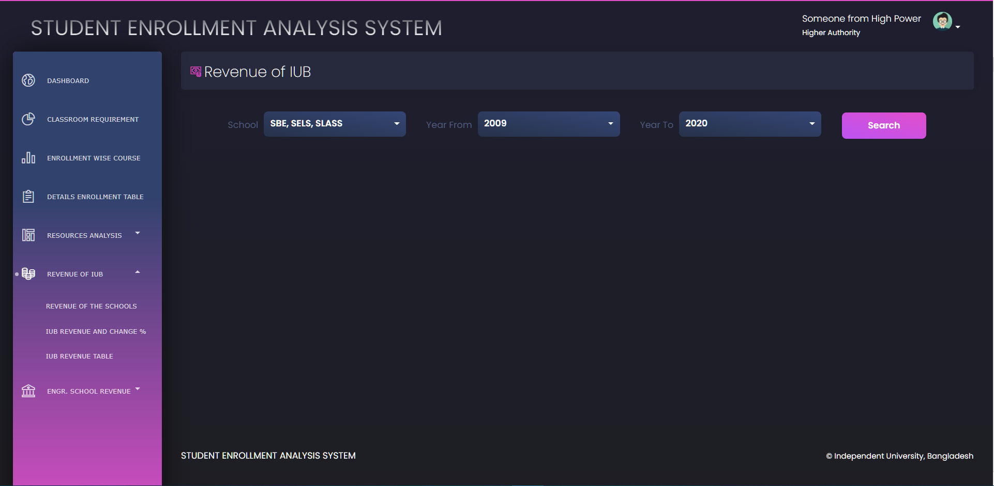

def view_revenue_table_of_iub(request):

    if request.method == 'POST':

        school = request.POST.getlist('scl')

        yearf = request.POST.get('year1')

        yeart = request.POST.get('year2')

        print(school, yearf, yeart)

        revenue = []

        rowsize=len(school)

        for i in school:

            revenue.append(iub_revenue(yearf, yeart, i))

*# print(revenue)*

        a = abs(int(yearf)-int(yeart))+1

*# print(type(a))*

        list1 = []

        list2 = []

        list3 = []

        total = []

        for j in revenue:

            for i in j:

                list1.append(str(i[0])+i[1])

                list2.append(int(i[2]))

        list1 = list(dict.fromkeys(list1))

        list2 = [list2[i:i+a*3] for i in range(0, len(list2), a*3)]

*#add missing spph to make col same for matrix*

        if "SPPH" in school:

            index=school.index("SPPH")

            dif = len(list1) - len(list2[index])

            if dif==1:

                list2[index].insert(1,0)

            if dif==2:

                list2[index].insert(1,0)

                list2[index].insert(4, 0)

            if dif == 3:

                list2[index].insert(1, 0)

                list2[index].insert(4, 0)

                list2[index].insert(7, 0)

        list3=np.transpose(list2)

        total = list3.sum(axis=1).tolist()

        change=[0,0,0]

        for i in range(len(total)-3):

            change.append(int(((total[i+3]-total[i])/total[i+3])*100))

        list2.append(total)

        list2.append(change)

        list2 = np.transpose(list2)

        finaltable = np.c_[list1, list2]

        print(finaltable)

        return render(request, 'revenuetableiub.html', {

            'schools': schoolList,

            'yearfrom': yearlist,

            'yearto': yearlist,

            'selectedschool': school,

            'yearf':yearf,

            'yeart':yeart,

            'table': finaltable,

            'rowsize':rowsize,

            'search': 0,

            'segment': 'rev',

        })

    else:

        return render(request, 'revenuetableiub.html', {

            'schools': schoolList,

            'yearfrom': yearlist,

            'yearto': yearlist,

            'search': 1,

            'segment': 'rev',

        })

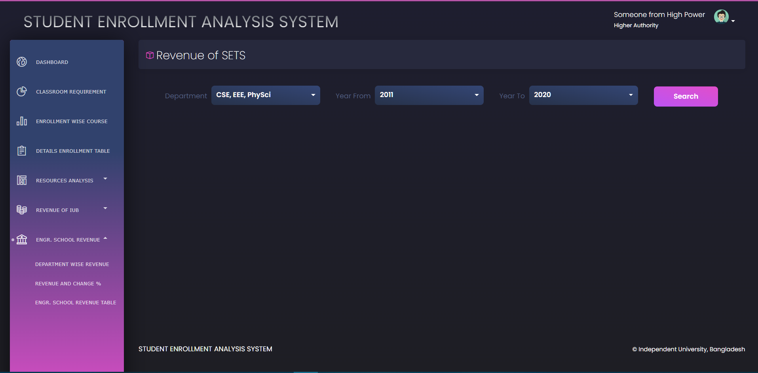

def view_sets_rev(request):

    if request.method == 'POST':

        dept = request.POST.getlist('dept')

        yearf = request.POST.get('year1')

        yeart = request.POST.get('year2')

        print(dept, yearf, yeart)

        revenue = []

        for i in dept:

            revenue.append(SETS_revenue(yearf, yeart, i))

        # print(revenue)

        a = abs(int(yearf)-int(yeart))+1

        # print(type(a))

        list1 = []

        list2 = []

        list3 = []

        total = []

        for j in revenue:

            for i in j:

                list1.append(str(i[0])+i[1])

                list2.append(int(i[2]))

        list1 = list(dict.fromkeys(list1))

        list2 = [list2[i:i+a*3] for i in range(0, len(list2), a*3)]

        print(list1)

        print(list2)

        return render(request, 'setsrev.html', {

            'dept': SETSdeptList,

            'yearfrom': yearlist,

            'yearto': yearlist,

            'selecteddept': dept,

            'revenuesemyear': list1,

            'revenue': list2,

            'search': 0,

            'segment': 'sets',

        })

    else:

        return render(request, 'setsrev.html', {

            'dept': SETSdeptList,

            'yearfrom': yearlist,

            'yearto': yearlist,

            'search': 1,

            'segment': 'sets',

        })

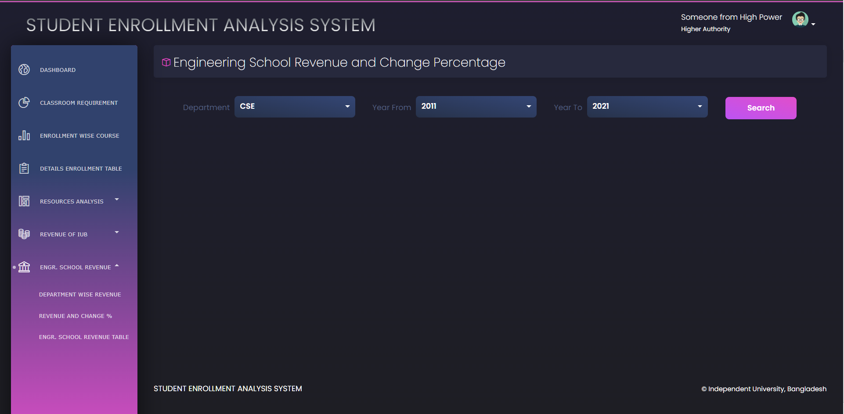

def view_deptwise_rev_per(request):

    if request.method == 'POST':

        dept = request.POST.get('dept')

        yearf = request.POST.get('year1')

        yeart = request.POST.get('year2')

        # print(dept, yearf, yeart)

        revenue = []

        revenue.append(SETS_revenue(yearf, yeart, dept))

        # print(revenue)

        y = abs(int(yearf)-int(yeart))+1

        # print(type(a))

        list1 = []

        list2 = []

        list3 = []

        list4 = []

        list5 = []

        list6 = []

        list7 = []

        list8 = []

        list9 = []

        list10 = []

        total = []

        for j in revenue:

            for i in j:

                list1.append(str(i[0])+i[1])

                list2.append(int(i[2]))

        list1 = list(dict.fromkeys(list1))

        total = list2

        list2 = [list2[i:i+3] for i in range(0, len(list2), 3)]

        print(list1)

        for i in list2:

            list3.append(i[0])

            list4.append(i[1])

            list5.append(i[2])

        for i in list3:

            # if(list3.index(i)<len(list3)):

            if list3.index(i) != 0:

                a = list3[abs(list3.index(i)-1)]

                b = i

                c = int(((b-a)/b)*100)

            else:

                a = list3[abs(list3.index(i))]

                b = i

                c = int(((b-a)/b)*100)

            list6.append(c)

        for i in list4:

            # if(list3.index(i)<len(list3)):

            if list4.index(i) != 0:

                a = list4[abs(list4.index(i)-1)]

                b = i

                c = int(((b-a)/b)*100)

            else:

                a = list4[abs(list4.index(i))]

                b = i

                c = int(((b-a)/b)*100)

            list7.append(c)

        for i in list5:

            # if(list3.index(i)<len(list3)):

            if list5.index(i) != 0:

                a = list5[abs(list5.index(i)-1)]

                b = i

                c = int(((b-a)/b)*100)

            else:

                a = list5[abs(list5.index(i))]

                b = i

                c = int(((b-a)/b)*100)

            list8.append(c)

        # for i in list8:

        for j in range(y):

            list9.append(list6[j])

            list9.append(list7[j])

            list9.append(list8[j])

        print(list9)

        return render(request, 'setsdeptper.html', {

            'dept': SETSdeptList,

            'yearfrom': yearlist,

            'yearto': yearlist,

            'selecteddept': dept,

            'revenuesemyear': list1,

            'revenue': list9,

            'totalrev': total,

            'search': 0,

            'segment': 'sets',

        })

    else:

        return render(request, 'setsdeptper.html', {

            'dept': SETSdeptList,

            'yearfrom': yearlist,

            'yearto': yearlist,

            'search': 1,

            'segment': 'sets',

        })

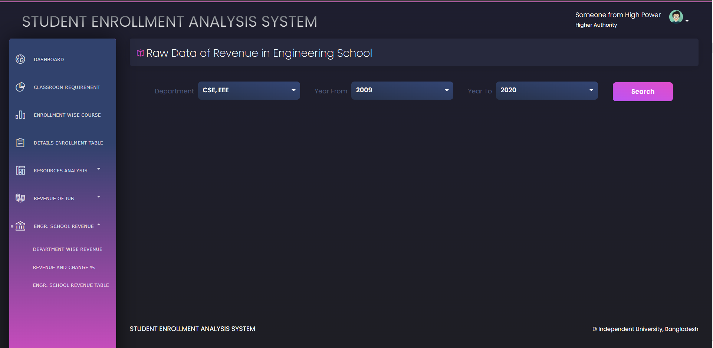

def view_engr_school_rev(request):

    if request.method == 'POST':

        dept = request.POST.getlist('dept')

        yearf = request.POST.get('year1')

        yeart = request.POST.get('year2')

        print(dept, yearf, yeart)

        revenue = []

        for i in dept:

           revenue.append(SETS_revenue(yearf,yeart,i))

        a = abs(int(yearf)-int(yeart))+1

*# print(type(a))*

        list1 = []

        list2 = []

        list3 = []

        total = []

        for j in revenue:

            for i in j:

                list1.append(str(i[0])+i[1])

                list2.append(int(i[2]))

        list1 = list(dict.fromkeys(list1))

        list2 = [list2[i:i+a*3] for i in range(0, len(list2), a*3)]

        list3 = np.transpose(list2)

        total = list3.sum(axis=1).tolist()

        change = []

        for i in range(len(list2)):

            change1 = [0,0,0]

            for j in range(len(list2[i])-3):

                change1.append(int(((list2[i][j+3]-list2[i][j])/list2[i][j+3])*100))

            change.append(change1)

        changet=[0,0,0]

        for i in range(len(total)-3):

            changet.append(int(((total[i+3]-total[i])/total[i+3])*100))

        change.append(changet)

        finaltemp1=np.transpose(change)

        list2.append(total)

        finaltemp2=np.transpose(list2)

        finaltemp3=np.concatenate((finaltemp2,finaltemp1),axis=1)

        finaltable = np.c_[list1, finaltemp3]

        tablehead=[]

        for i in range(len(dept)):

            tablehead.append(dept[i])

        tablehead.append("SETS")

        for i in range(len(dept)):

            tablehead.append(dept[i]+"%")

        tablehead.append("SETS%")

        print(tablehead)

        return render(request, 'setsrevtable.html', {

            'dept': SETSdeptList,

            'yearfrom': yearlist,

            'yearto': yearlist,

            'yearf': yearf,

            'yeart': yeart,

            'table': finaltable,

            'selecteddept':dept,

            'tablehead': tablehead,

            'search': 0,

            'segment': 'sets',

        })

    else:

        return render(request, 'setsrevtable.html', {

            'dept': SETSdeptList,

            'yearfrom': yearlist,

            'yearto': yearlist,

            'search': 1,

            'segment': 'sets',

        })

## B. OUTPUT FORMS:

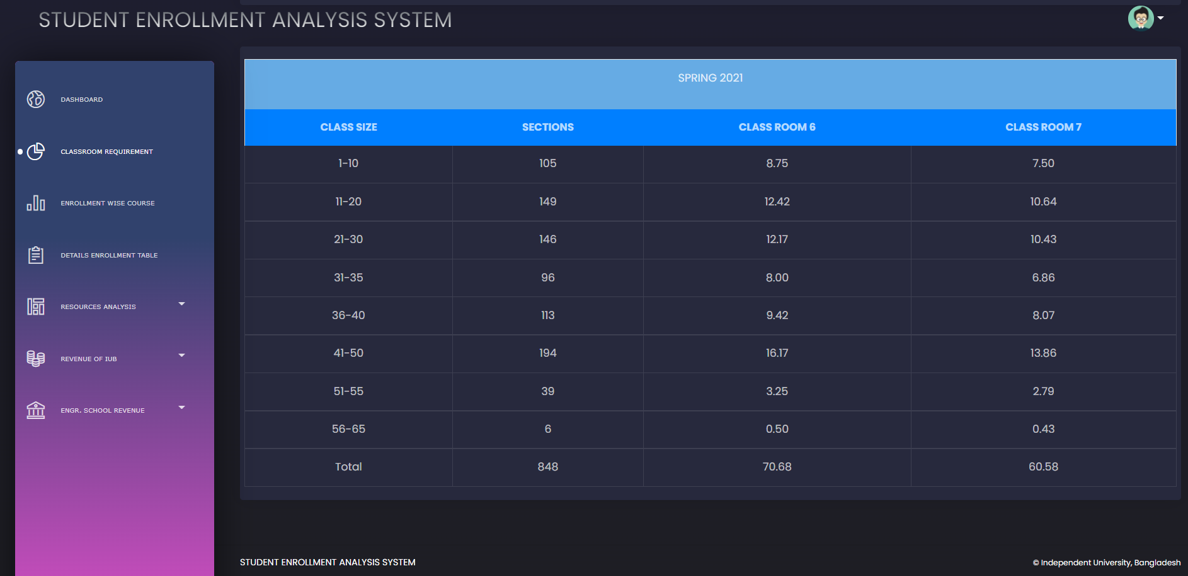

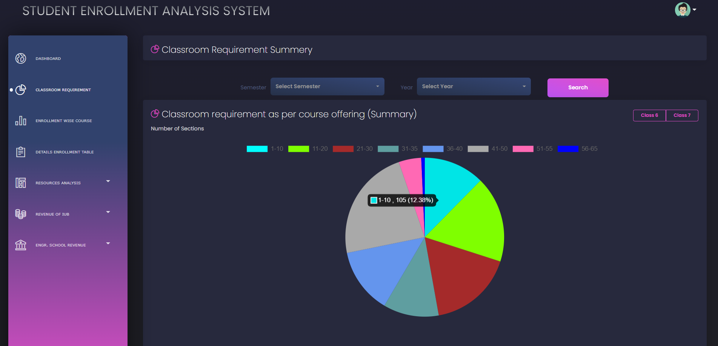

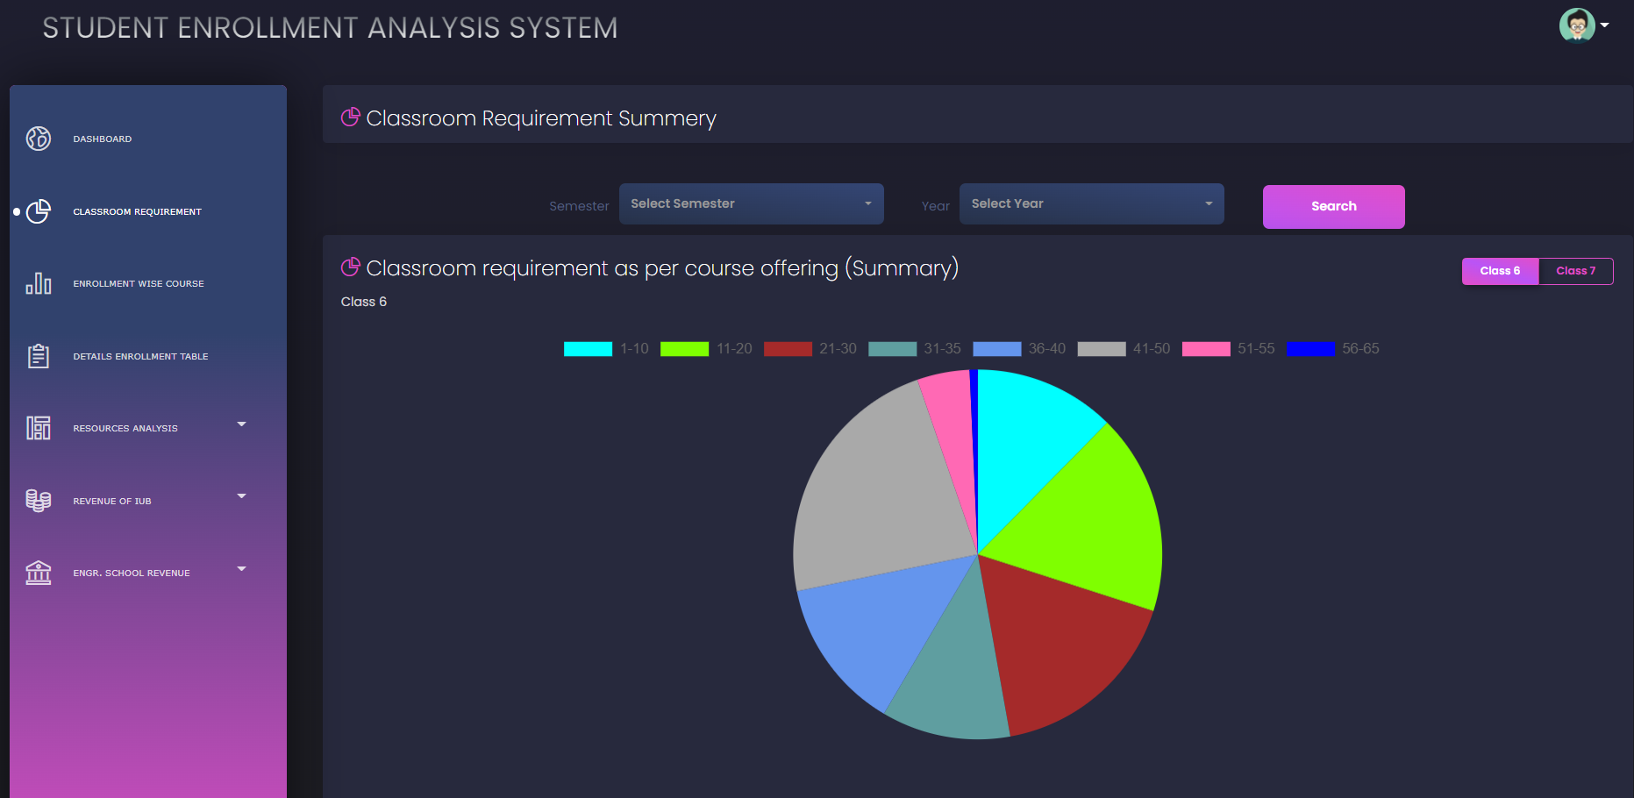

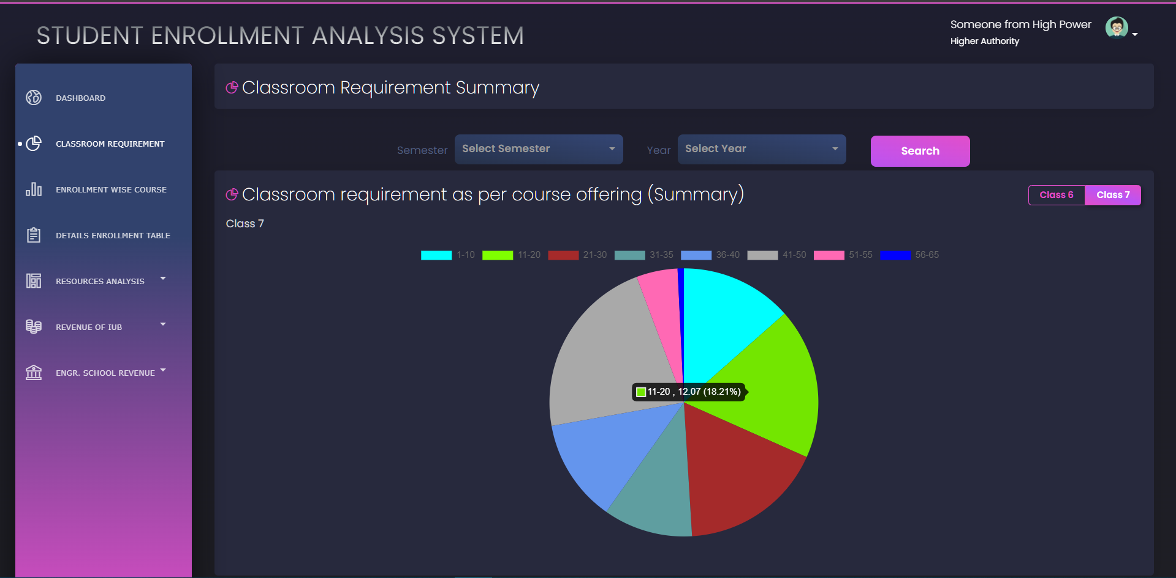

def classroom_requirement_course_offer(Sem, Year):

    with connection.cursor() as cursor:

        cursor.execute('''

        SELECT COUNT(*) AS Sections

        FROM joinedtable

        WHERE SectionEnrolled BETWEEN 1 AND 10

        AND semester = "{}"

        AND YEAR ={}

        UNION ALL

        SELECT COUNT(*)

        FROM joinedtable

        WHERE SectionEnrolled BETWEEN 11 AND 20

        AND semester = "{}"

        AND YEAR ={}

        UNION ALL

        SELECT COUNT(*)

        FROM joinedtable

        WHERE SectionEnrolled BETWEEN 21 AND 30

        AND semester = "{}"

        AND YEAR ={}

        UNION ALL

        SELECT COUNT(*)

        FROM joinedtable

        WHERE SectionEnrolled BETWEEN 31 AND 35

        AND semester = "{}"

        AND YEAR ={}

        UNION ALL

        SELECT COUNT(*)

        FROM joinedtable

        WHERE SectionEnrolled BETWEEN 36 AND 40

        AND semester = "{}"

        AND YEAR ={}

        UNION ALL

        SELECT COUNT(*)

        FROM joinedtable

        WHERE SectionEnrolled BETWEEN 41 AND 50

        AND semester = "{}"

        AND YEAR ={}

        UNION ALL

        SELECT COUNT(*)

        FROM joinedtable

        WHERE SectionEnrolled BETWEEN 51 AND 55

        AND semester = "{}"

        AND YEAR ={}

        UNION ALL

        SELECT COUNT(*)

        FROM joinedtable

        WHERE SectionEnrolled BETWEEN 56 AND 65

        AND semester = "{}"

        AND YEAR ={}

        '''.format(Sem, Year, Sem, Year, Sem, Year, Sem, Year, Sem, Year, Sem, Year, Sem, Year, Sem, Year))

        sections=[]

        col = cursor.fetchall()

        for i in col:

            for j in i:

                sections.append(j)

    return (sections)

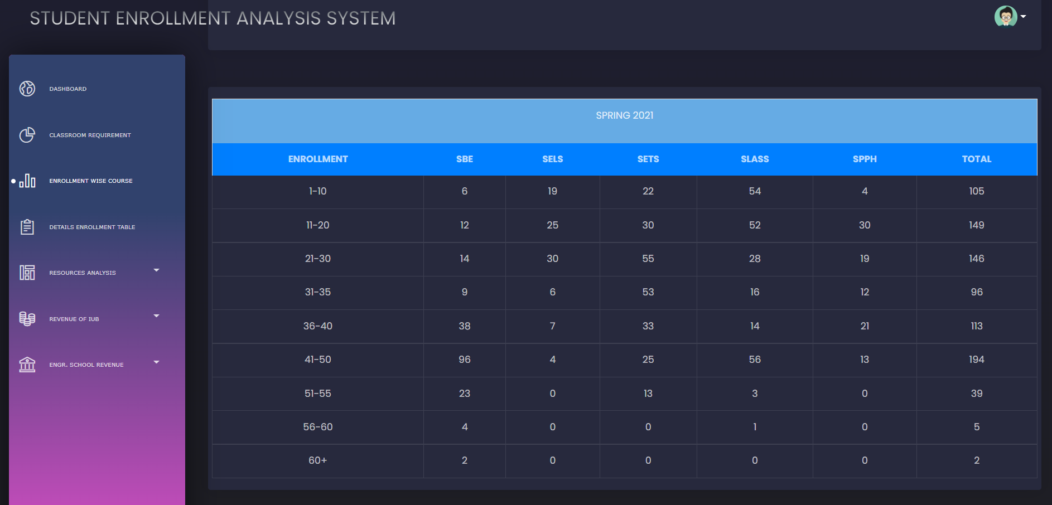

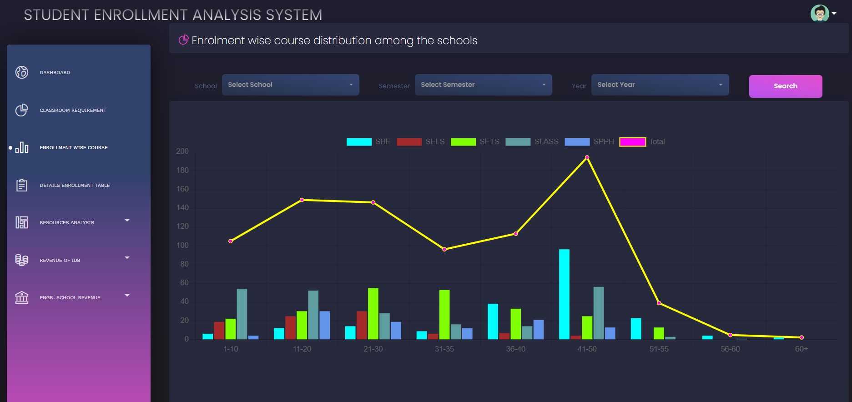

def enrollment_wise_course_school(School, Sem, Year):

    with connection.cursor() as cursor:

        cursor.execute('''

        SELECT COUNT(*)

        FROM joinedtable

        WHERE SchoolTitle_id="{}" AND Semester="{}" AND Year={} AND SectionEnrolled BETWEEN 1 AND 10

        UNION ALL

        SELECT COUNT(*)

        FROM joinedtable

        WHERE SchoolTitle_id="{}" AND Semester="{}" AND Year={} AND SectionEnrolled BETWEEN 11 AND 20

        UNION ALL

        SELECT COUNT(*)

        FROM joinedtable

        WHERE SchoolTitle_id="{}" AND Semester="{}" AND Year={} AND SectionEnrolled BETWEEN 21 AND 30

        UNION ALL

        SELECT COUNT(*)

        FROM joinedtable

        WHERE SchoolTitle_id="{}" AND Semester="{}" AND Year={} AND SectionEnrolled BETWEEN 31 AND 35

        UNION ALL

        SELECT COUNT(*)

        FROM joinedtable

        WHERE SchoolTitle_id="{}" AND Semester="{}" AND Year={} AND SectionEnrolled BETWEEN 36 AND 40

        UNION ALL

        SELECT COUNT(*)

        FROM joinedtable

        WHERE SchoolTitle_id="{}" AND Semester="{}" AND Year={} AND SectionEnrolled BETWEEN 41 AND 50

        UNION ALL

        SELECT COUNT(*)

        FROM joinedtable

        WHERE SchoolTitle_id="{}" AND Semester="{}" AND Year={} AND SectionEnrolled BETWEEN 51 AND 55

        UNION ALL

        SELECT COUNT(*)

        FROM joinedtable

        WHERE SchoolTitle_id="{}" AND Semester="{}" AND Year={} AND SectionEnrolled BETWEEN 56 AND 60

        UNION ALL

        SELECT COUNT(*)

        FROM joinedtable

        WHERE SchoolTitle_id="{}" AND Semester="{}" AND Year={} AND SectionEnrolled > 60

        '''.format(School, Sem, Year, School, Sem, Year, School, Sem, Year, School, Sem, Year, School, Sem, Year, School, Sem, Year, School, Sem, Year, School, Sem, Year, School, Sem, Year))

        col = cursor.fetchall()

    return col

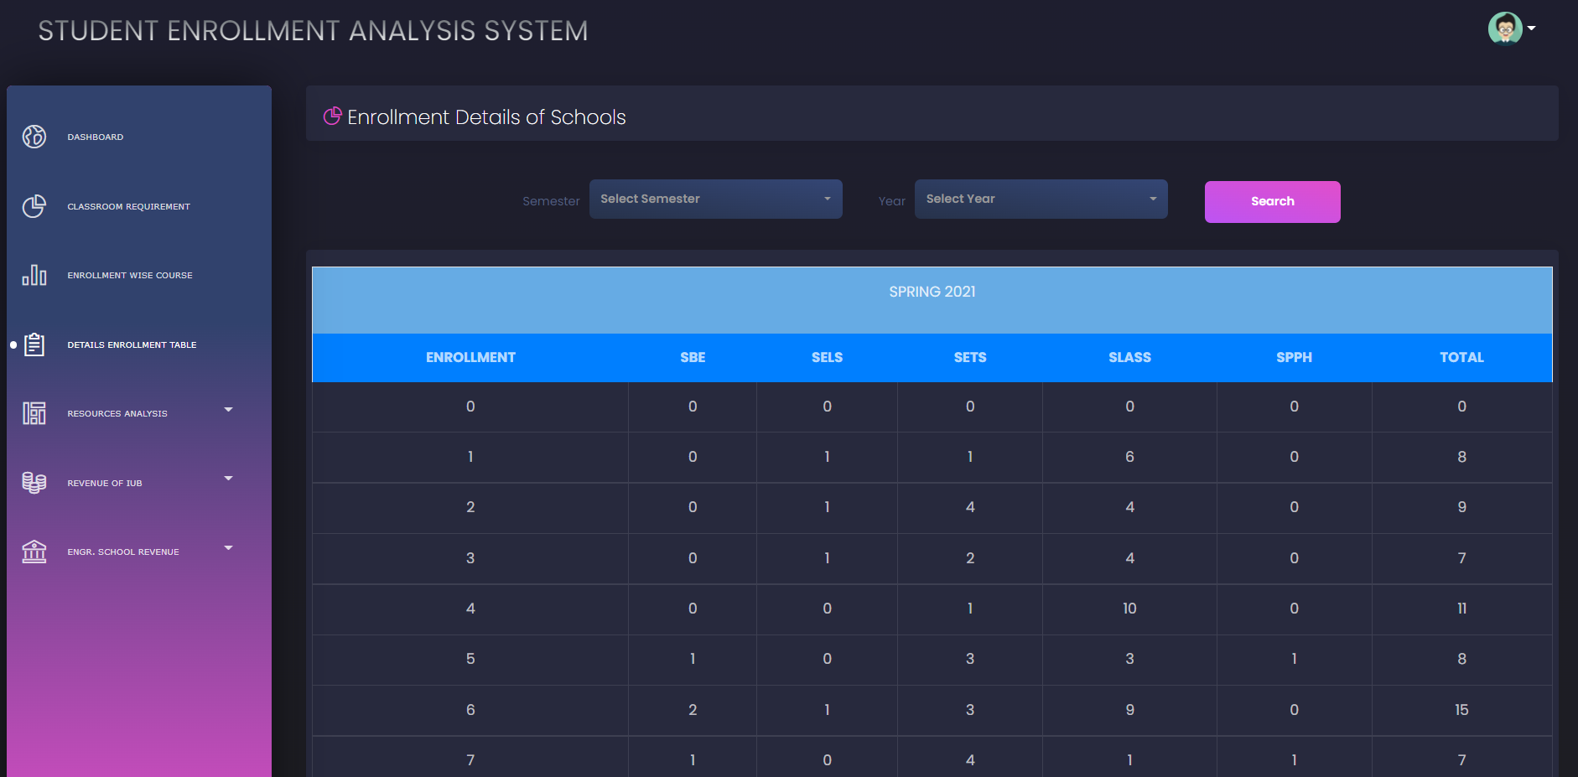

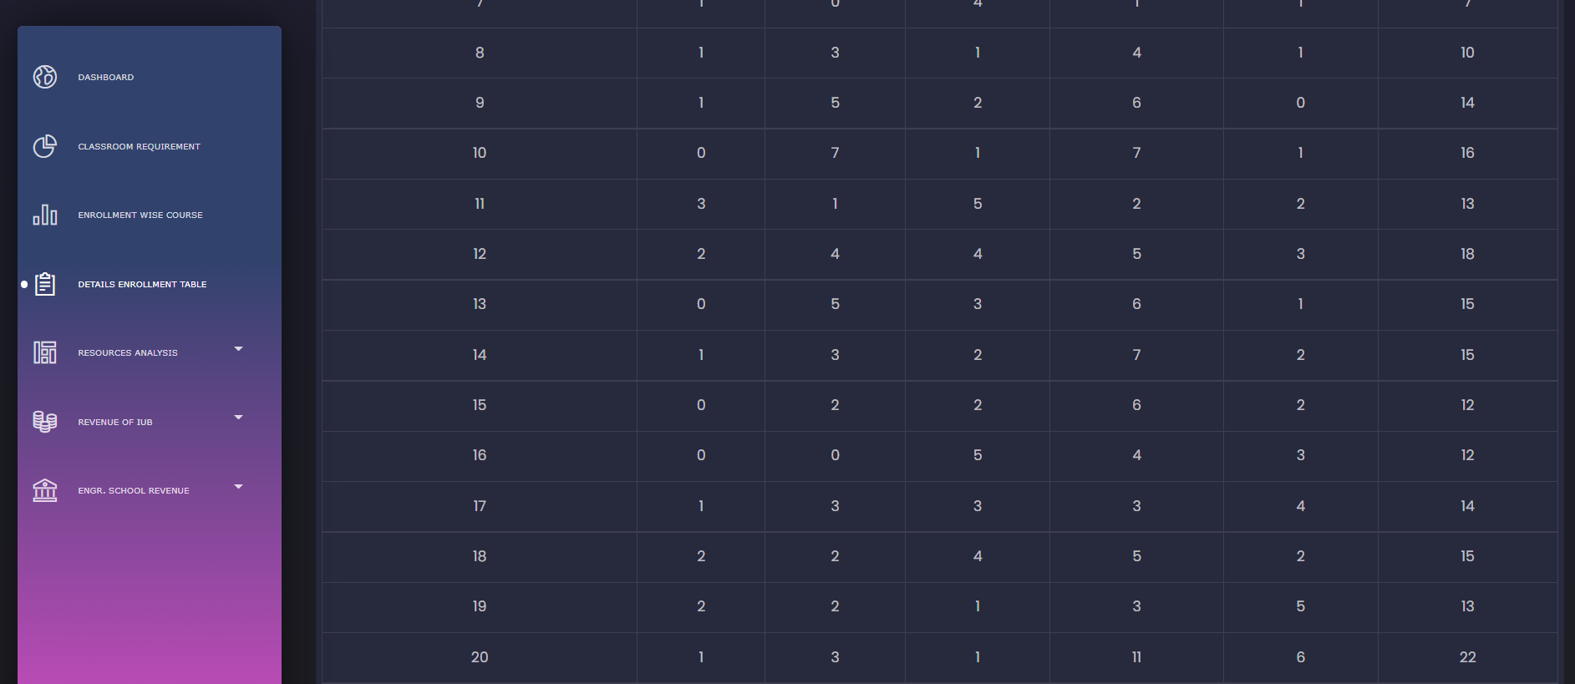

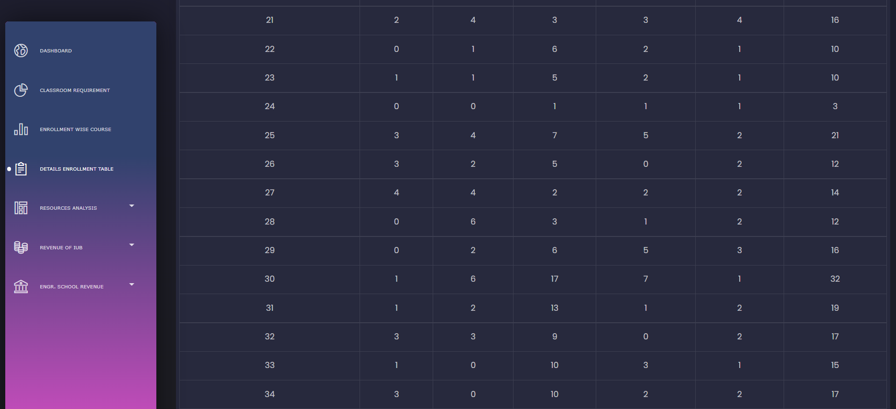

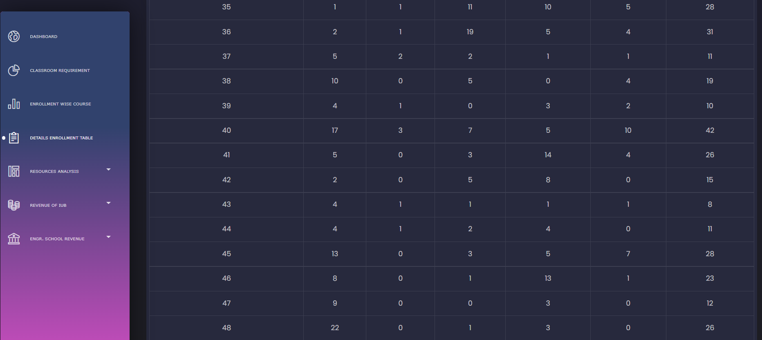

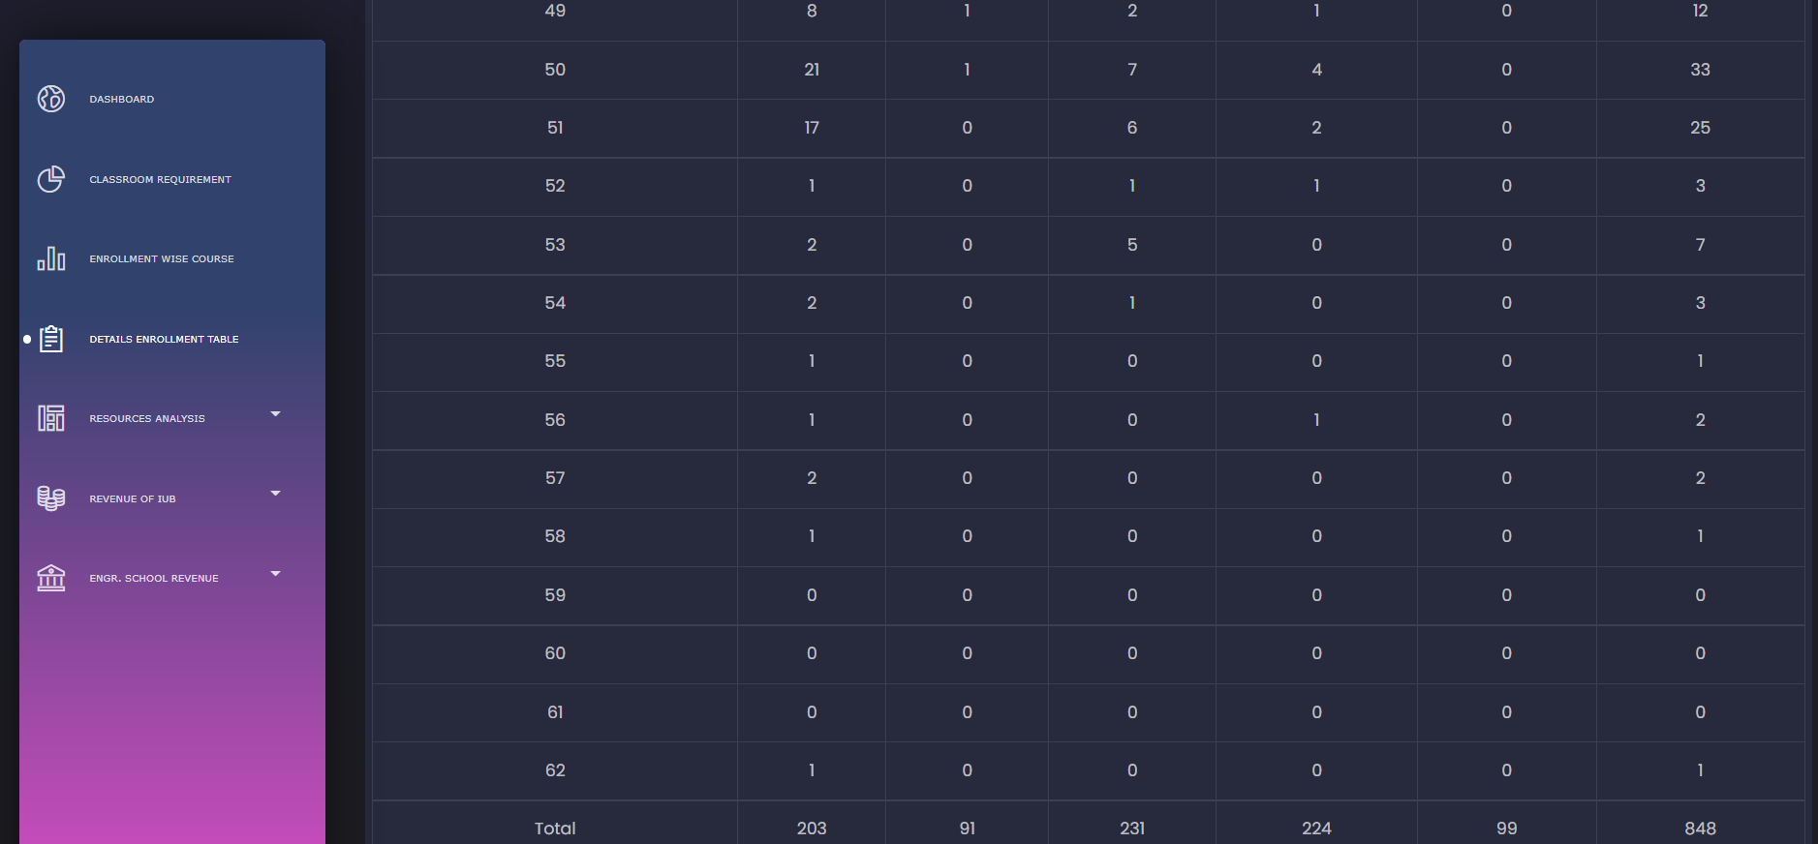

def details_enrollment(School, Sem, Year):

    with connection.cursor() as cursor:

        cursor.execute('''

        SELECT SectionEnrolled, COUNT(*) AS SBE

        FROM joinedtable

        WHERE SchoolTitle_id="{}" AND Semester="{}" AND Year = {} AND SectionEnrolled BETWEEN 1 AND 100

        GROUP BY SectionEnrolled

        HAVING SectionEnrolled > 0

        ORDER BY SectionEnrolled ASC;

        '''.format(School, Sem, Year))

        col = cursor.fetchall()

    return col

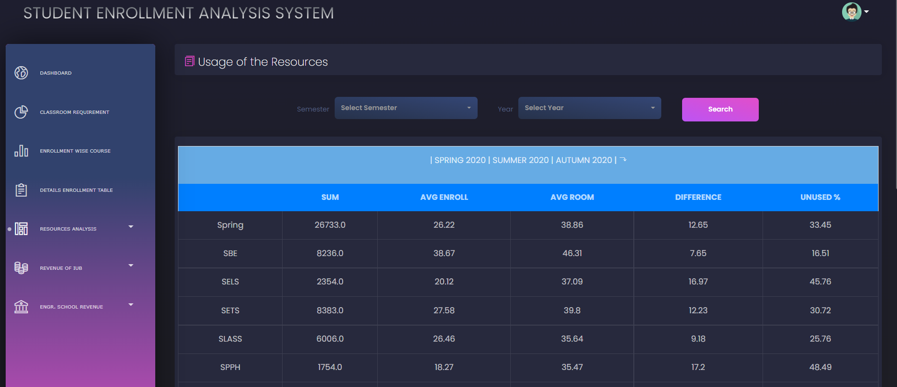

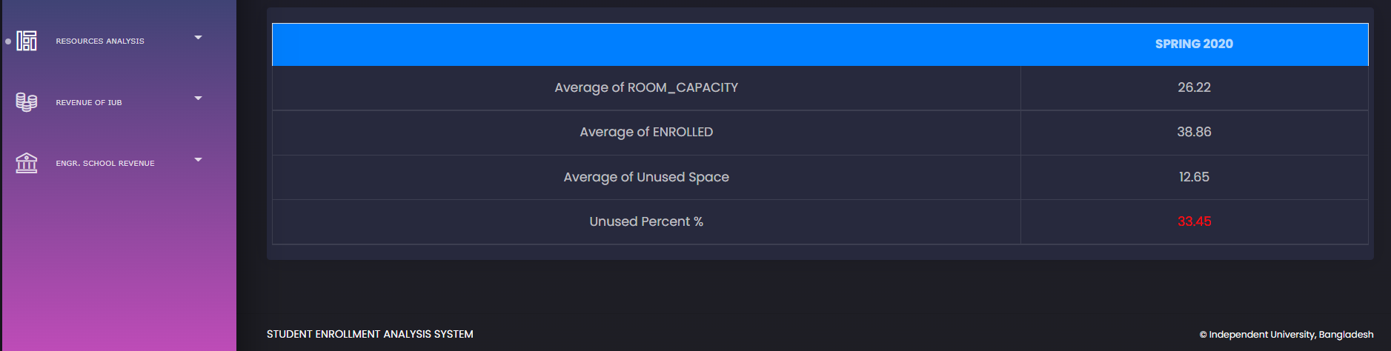

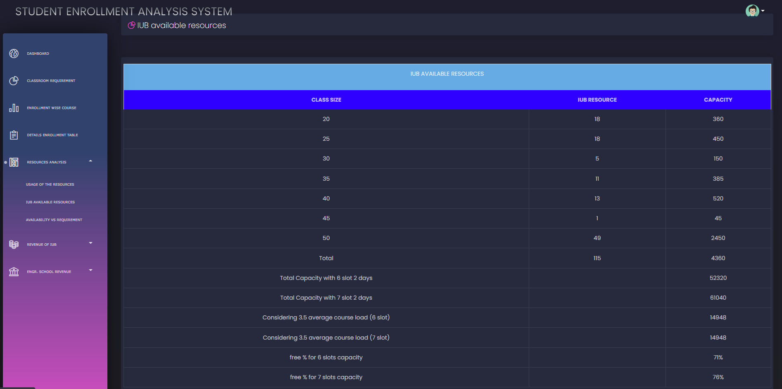

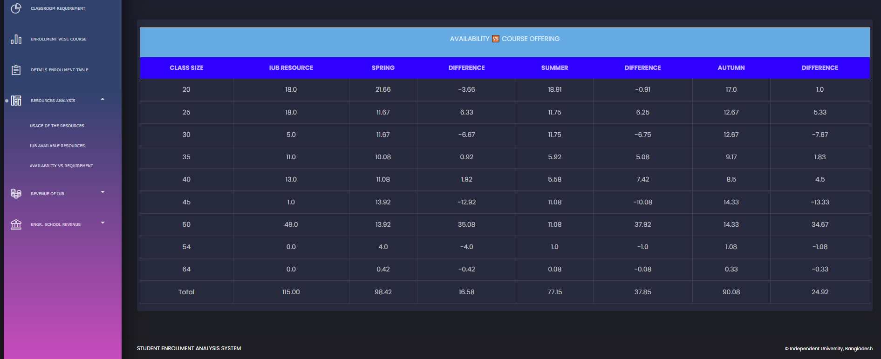

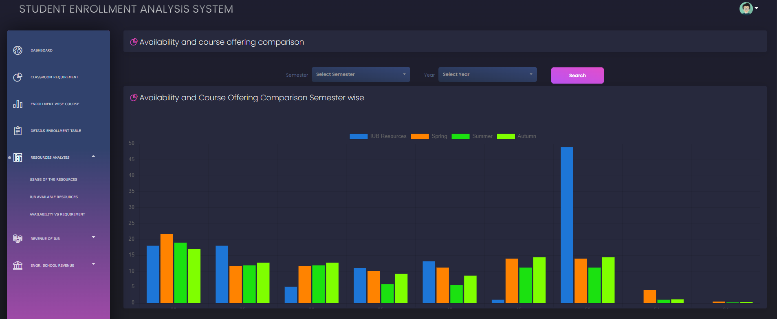

def resources_usage(School, Sem, Year):

    with connection.cursor() as cursor:

        cursor.execute('''

        SELECT SUM(sectionEnrolled) AS Sum

        FROM joinedtable

        WHERE SchoolTitle_id="{}" AND Semester="{}" AND Year={}

        UNION ALL

        SELECT AVG(sectionEnrolled)

        FROM joinedtable

        WHERE SchoolTitle_id="{}" AND Semester="{}" AND Year={}

        UNION ALL

        SELECT AVG(roomCapacity)

        FROM joinedtable

        JOIN seasapp_room_t

        ON RoomID_id= RoomID

        WHERE SchoolTitle_id="{}" AND Semester="{}" AND Year={}

        UNION ALL

        SELECT AVG(roomCapacity)-Avg(sectionEnrolled) AS difference

        FROM joinedtable

        JOIN seasapp_room_t

        ON RoomID_id= RoomID

        WHERE SchoolTitle_id="{}" AND Semester="{}" AND Year={}

        UNION ALL

        SELECT ((AVG(roomCapacity)-Avg(sectionEnrolled))/AVG(RoomCapacity))*100 AS percentage

        FROM joinedtable

        JOIN seasapp_room_t

        ON RoomID_id= RoomID

        WHERE SchoolTitle_id="{}" AND Semester="{}" AND Year={}

        '''.format(School, Sem, Year, School, Sem, Year, School, Sem, Year, School, Sem, Year, School, Sem, Year))

        row = cursor.fetchall()

    return row

def roomsizelist():

    with connection.cursor() as cursor:

        cursor.execute('''

        SELECT roomcapacity,COUNT(roomcapacity)

        FROM seasapp_room_t

        GROUP BY roomcapacity

        ORDER BY roomcapacity;

        ''')

        col = cursor.fetchall()

    return col

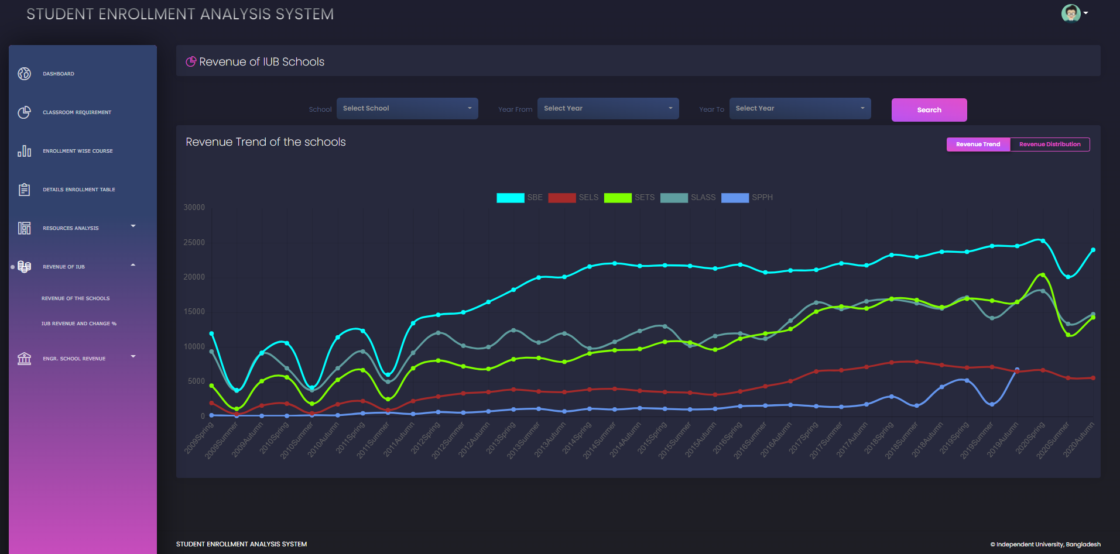

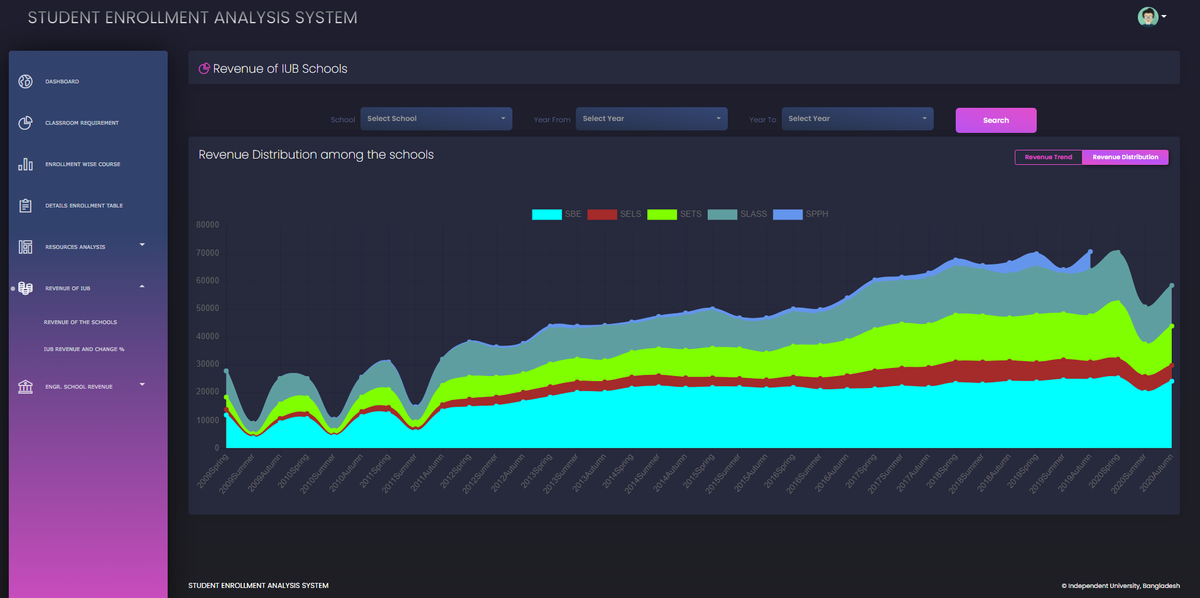

def iub_revenue(Yearfrom, Yearto, School):

    with connection.cursor() as cursor:

        cursor.execute('''

        SELECT Year,Semester,SUM(groupbycredit.sum)

        FROM

            (

                SELECT COUNT(*),credithour, SUM( SectionEnrolled), credithour*SUM( SectionEnrolled) AS sum, Semester,year

                FROM joinedtable

                WHERE Semester IN ("Spring","AUTUMN","SUMMER") AND Year BETWEEN {} AND {} AND SchoolTitle_id = "{}"

                GROUP BY Year,Semester,Credithour

            ) AS groupbycredit

        GROUP BY Year,Semester

        ORDER BY Year, FIELD (Semester,"Spring","Summer","Autumn");

        '''.format(Yearfrom, Yearto, School))

        col = cursor.fetchall()

    return col

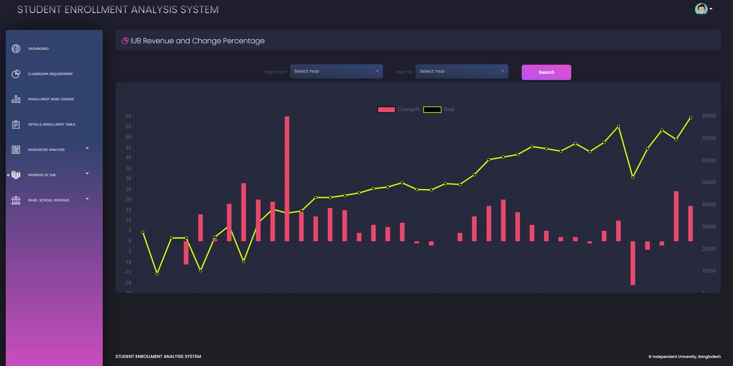

def iub_revenue_total(Yearfrom, Yearto):

    with connection.cursor() as cursor:

        cursor.execute('''

        SELECT Year,Semester,SUM(groupbycredit.sum)

        FROM

            (

                SELECT COUNT(*),credithour, SUM( SectionEnrolled), credithour*SUM( SectionEnrolled) AS sum, Semester,year

                FROM joinedtable

                WHERE Semester IN ("Spring","AUTUMN","SUMMER") AND Year BETWEEN {} AND {} AND SchoolTitle_id IN ('SBE', 'SELS', 'SETS', 'SLASS', 'SPPH')

                GROUP BY Year,Semester,Credithour

            ) AS groupbycredit

        GROUP BY Year,Semester

        ORDER BY Year, FIELD (Semester,"Spring","Summer","Autumn");

        '''.format(Yearfrom, Yearto))

        row = cursor.fetchall()

    return row

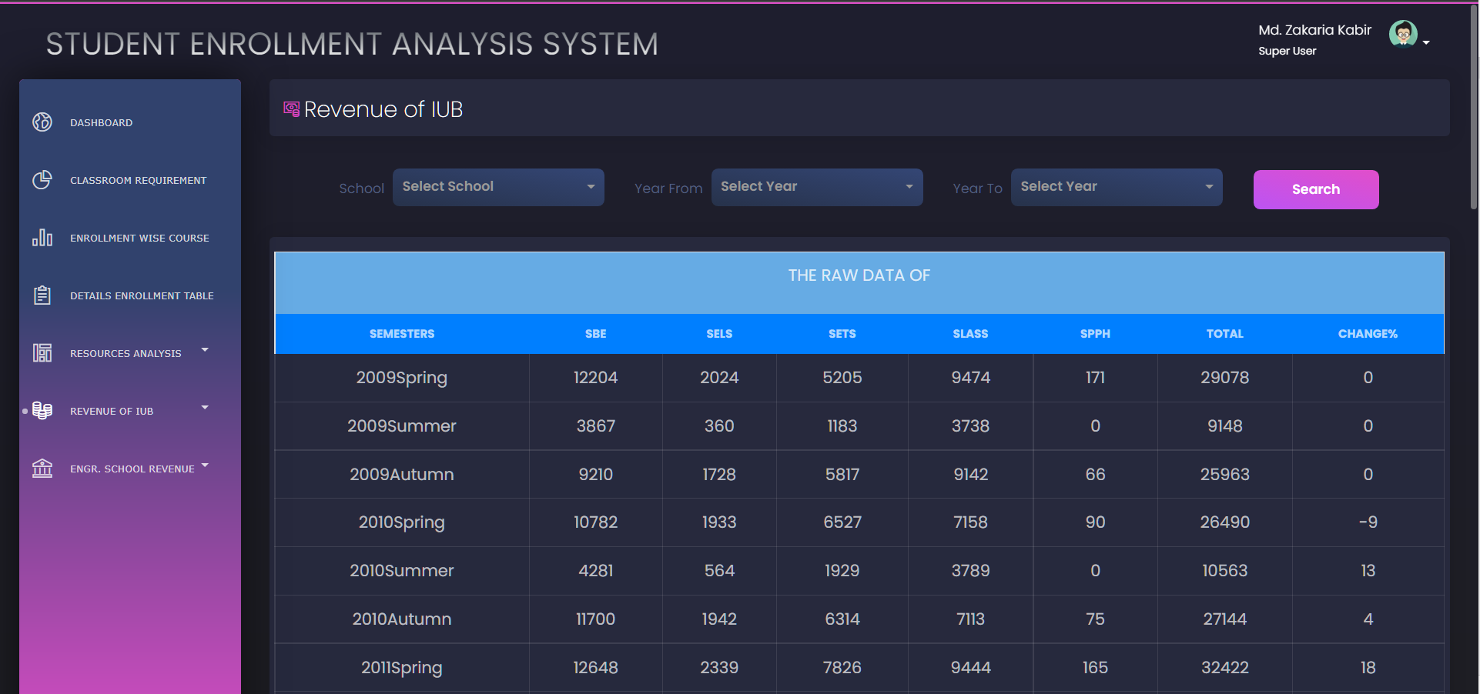

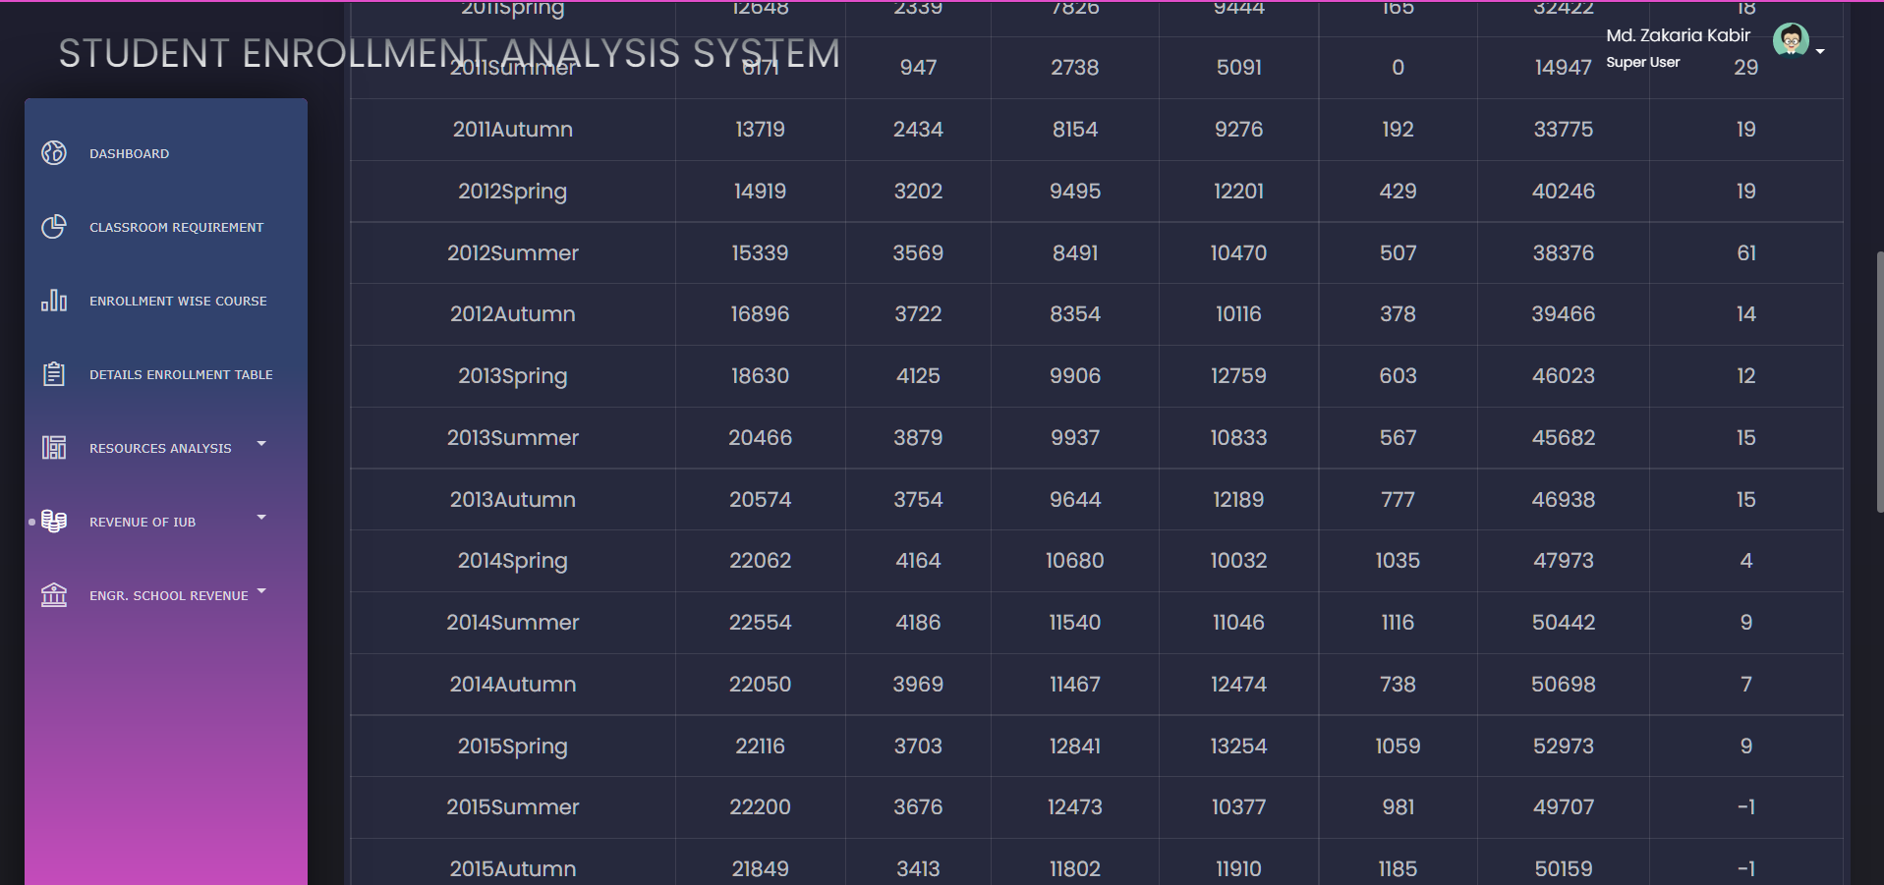

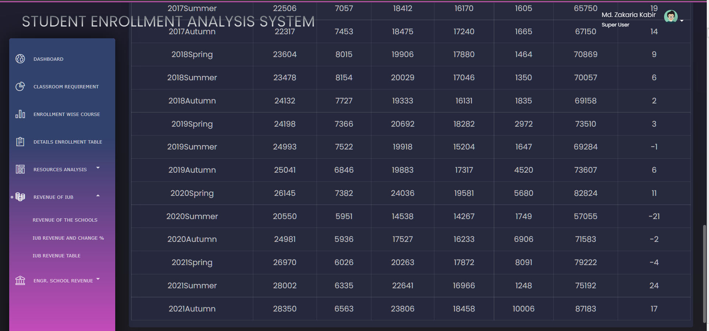

def iub_revenue(Yearfrom, Yearto, School):

    with connection.cursor() as cursor:

        cursor.execute('''

        SELECT Year,Semester,SUM(groupbycredit.sum)

        FROM

            (

                SELECT COUNT(*),credithour, SUM( SectionEnrolled), credithour*SUM( SectionEnrolled) AS sum, Semester,year

                FROM joinedtable

                WHERE Semester IN ("Spring","AUTUMN","SUMMER") AND Year BETWEEN {} AND {} AND SchoolTitle_id = "{}"

                GROUP BY Year,Semester,Credithour

            ) AS groupbycredit

        GROUP BY Year,Semester

        ORDER BY Year, FIELD (Semester,"Spring","Summer","Autumn");

        '''.format(Yearfrom, Yearto, School))

        col = cursor.fetchall()

    return col

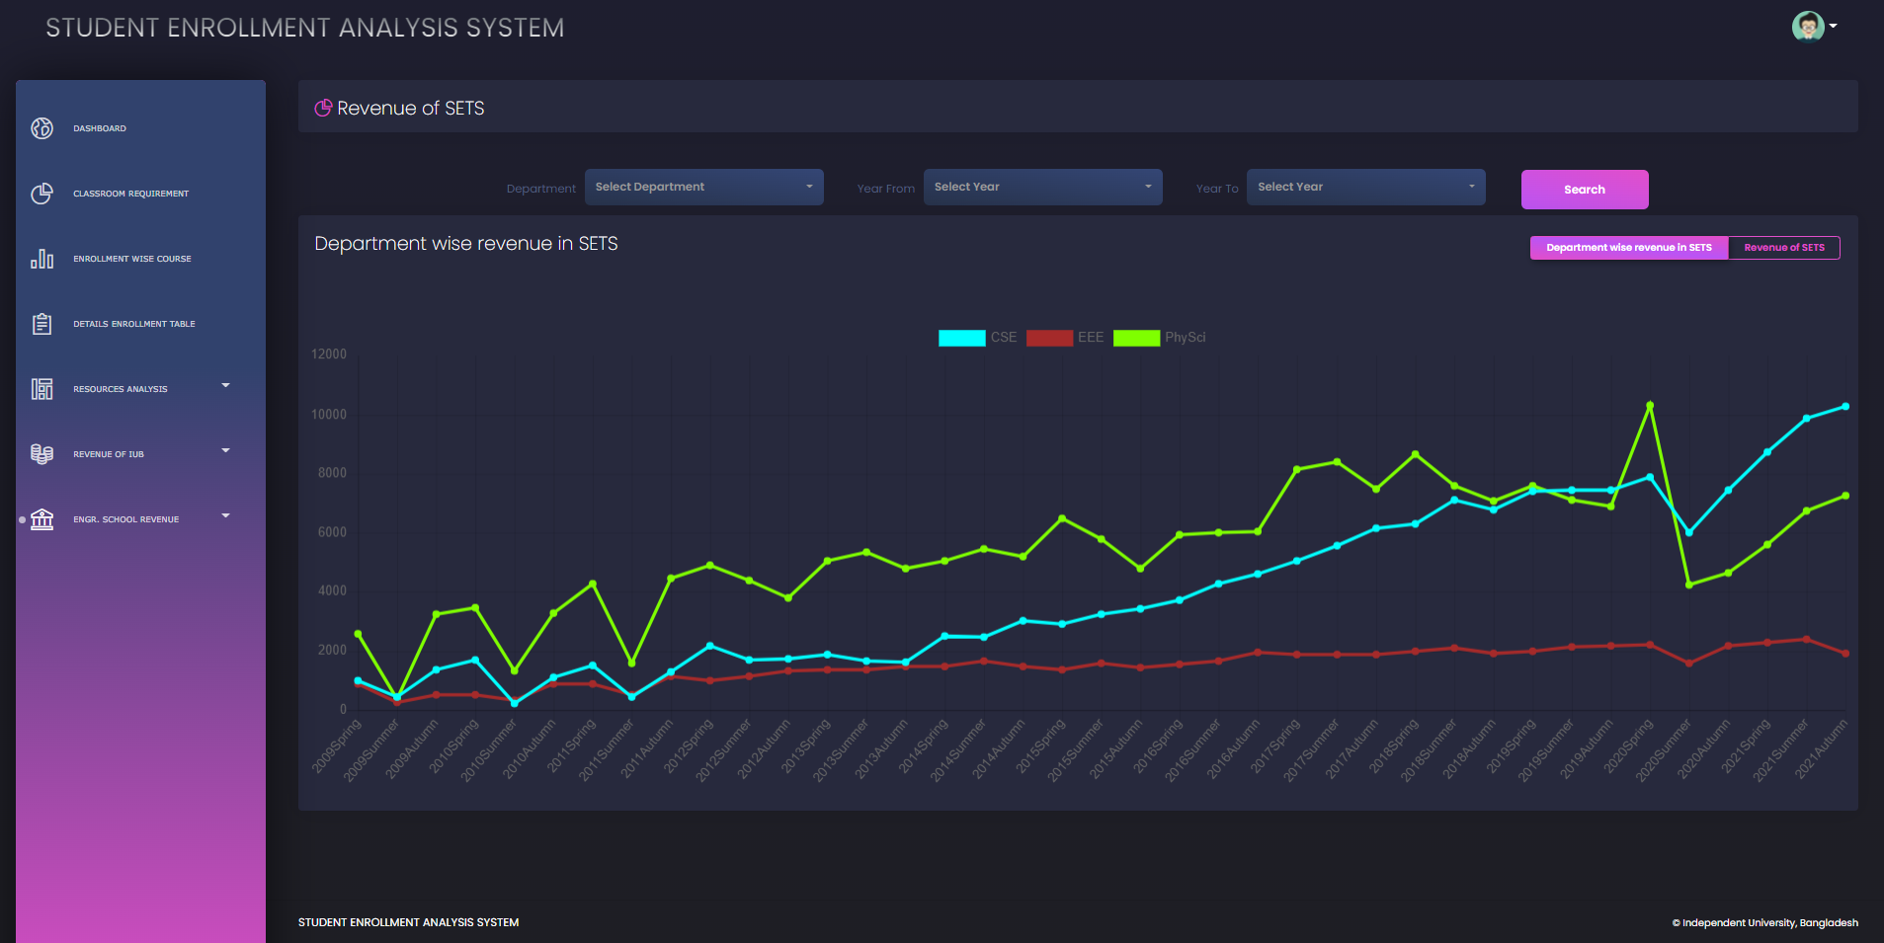

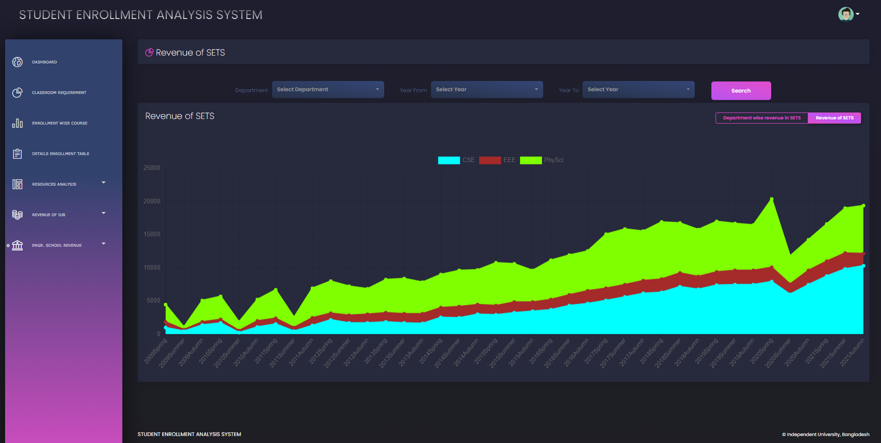

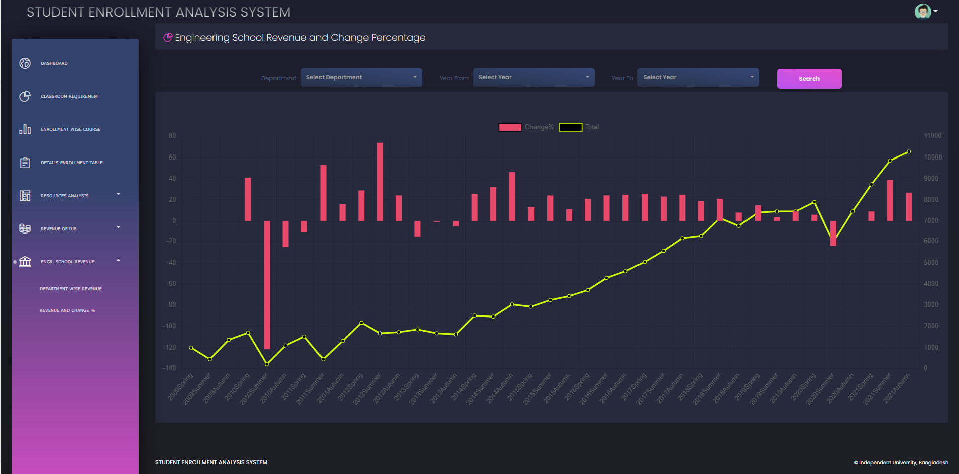

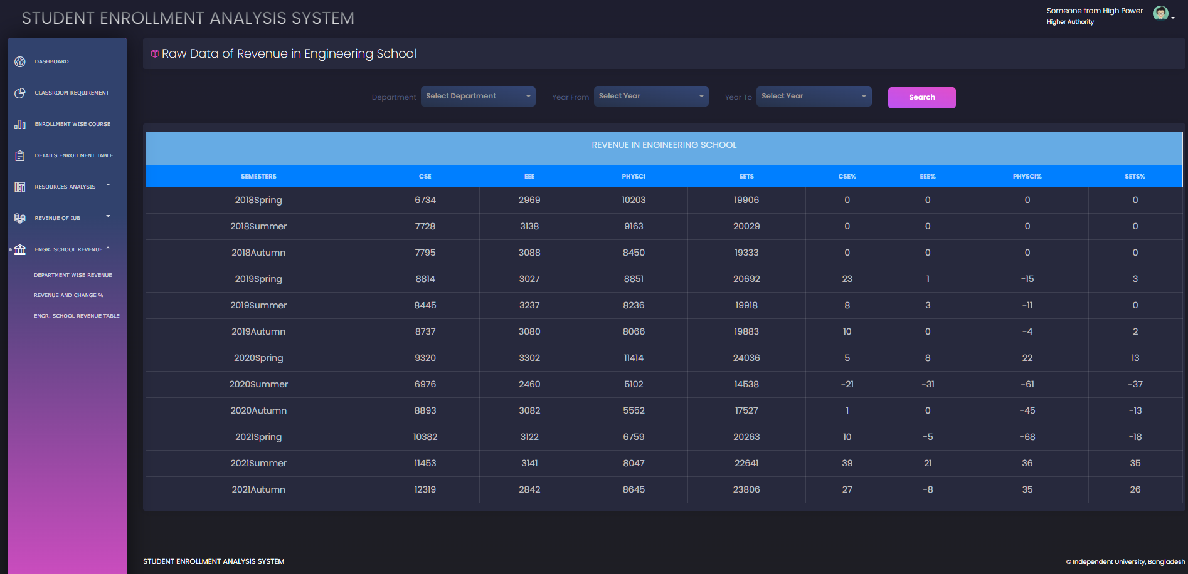

def SETS_revenue(Yearfrom, Yearto, Dept):

    with connection.cursor() as cursor:

        cursor.execute('''

        SELECT Year,Semester,SUM(groupbycredit.sum)

        FROM

            (

                SELECT COUNT(*),credithour, SUM( SectionEnrolled), credithour*SUM( SectionEnrolled) AS sum, Semester,year

                FROM joinedtable

                WHERE Semester IN ("Spring","AUTUMN","SUMMER") AND Year BETWEEN {} AND {} AND SchoolTitle_id = "SETS" AND DeptID = "{}"

                GROUP BY Year,Semester,Credithour

            ) AS groupbycredit

        GROUP BY Year,Semester

        ORDER BY Year, FIELD (Semester,"Spring","Summer","Autumn");

        '''.format(Yearfrom, Yearto, Dept))

        col = cursor.fetchall()

    return col

# CHAPTER 5 - CONCLUSION:

## A. PROBLEM AND SOLUTION:

### i. Analysis Phase

Because there was no discrete data present, the majority of assumptions and queries were made while working on the rich picture and six element analysis of the organization's operations, which were based on project SEAS developers. To better understand the scenario and clear up any confusions, feedback sessions were held with respected faculty members.

### ii. Designing Phase

Based upon descriptive research created entities were kept at their Significant levels, which was also introduced in the Relational Schema schematic. The instructor's feedback was also very valid and crucial in this case.

### iii. Implementation Phase

All the Software System Requirement’s (SSR’s) reached successfully!

Front-End Developing tools: HTML, CSS, Bootstrap JavaScript, Chart Js

Back End Developing tools: Python, Django

Database-integration: MySQL

## **B. ADDITIONAL FEATURE AND FUTURE** **DEVELOPMENT:**

Future Developing Purposes:

* + Plans for the project is, to add another feature which can predict classroom requirement size for the upcoming semester, providing better resource utilization.
  + Deployment.

# References

|  |  |
| --- | --- |
| [1] | "IUB AT A GLANCE," Department of Computer Science and Engineering, [Online]. Available: <http://www.iub.edu.bd/AboutIUB/ataglance>. |